Lenin on Wars Being Born out of Private Property
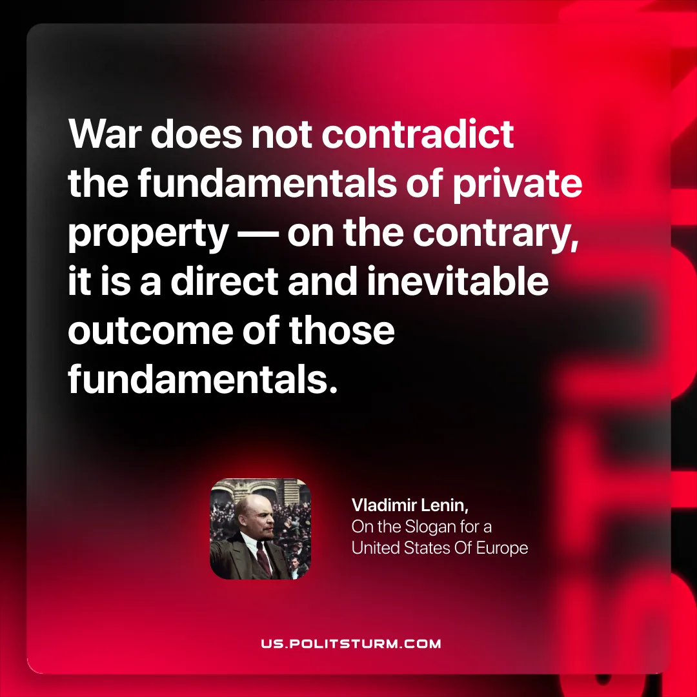

Original article
2025-10-16

"War does not contradict the fundamentals of private property — on the contrary, it is a direct and inevitable outcome of those fundamentals."
Vladimir Lenin, Slogan For A United States Of Europe

Original article

