Lenin on Opportunists Using Marx to Deceive the Workers
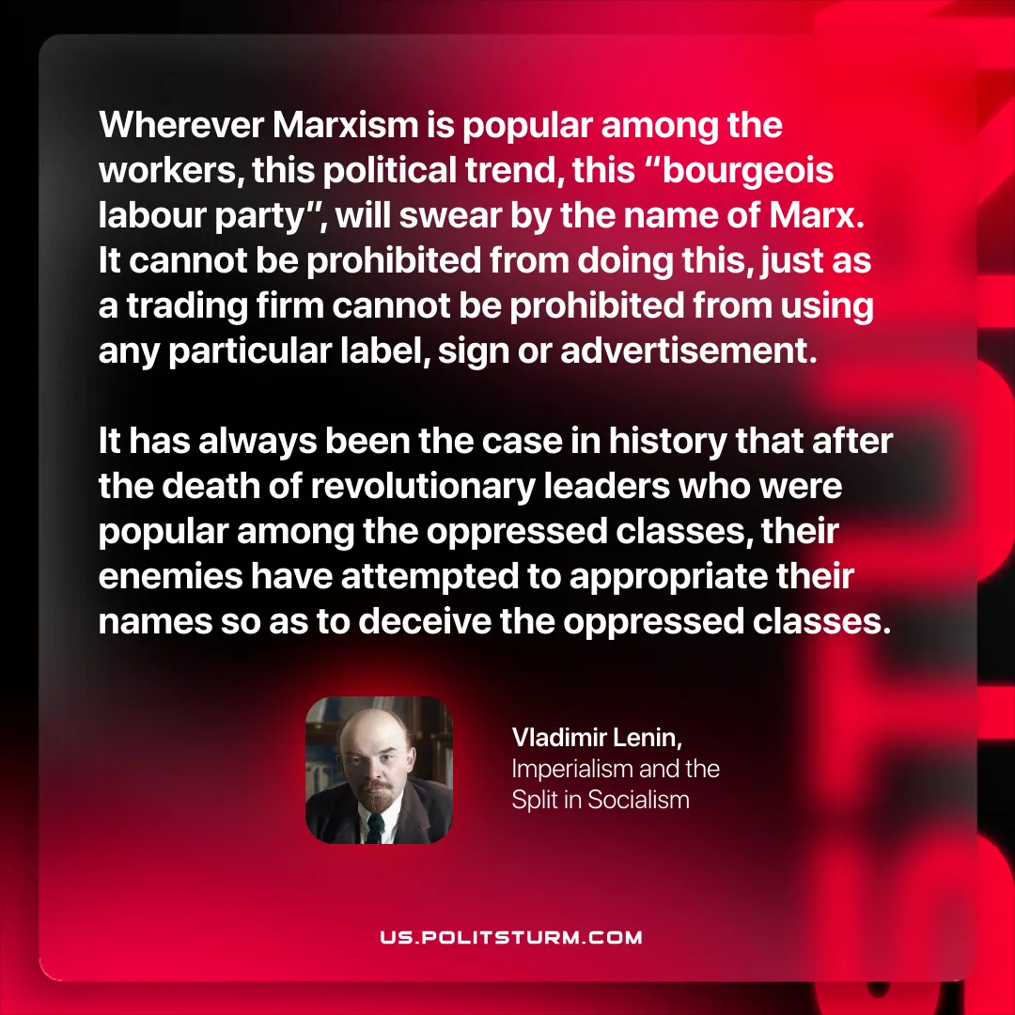

Original article
2025-10-04
1 min read

“Wherever Marxism is popular among the workers, this political trend, this “bourgeois labour party”, will swear by the name of Marx. It cannot be prohibited from doing this, just as a trading firm cannot be prohibited from using any particular label, sign or advertisement. It has always been the case in history that after the death of revolutionary leaders who were popular among the oppressed classes, their enemies have attempted to appropriate their names so as to deceive the oppressed classes.”
Vladimir Lenin, Imperialism and the Split in Socialism

Original article

