Stalin on how Capitalist Interests are Opposed to the Workers
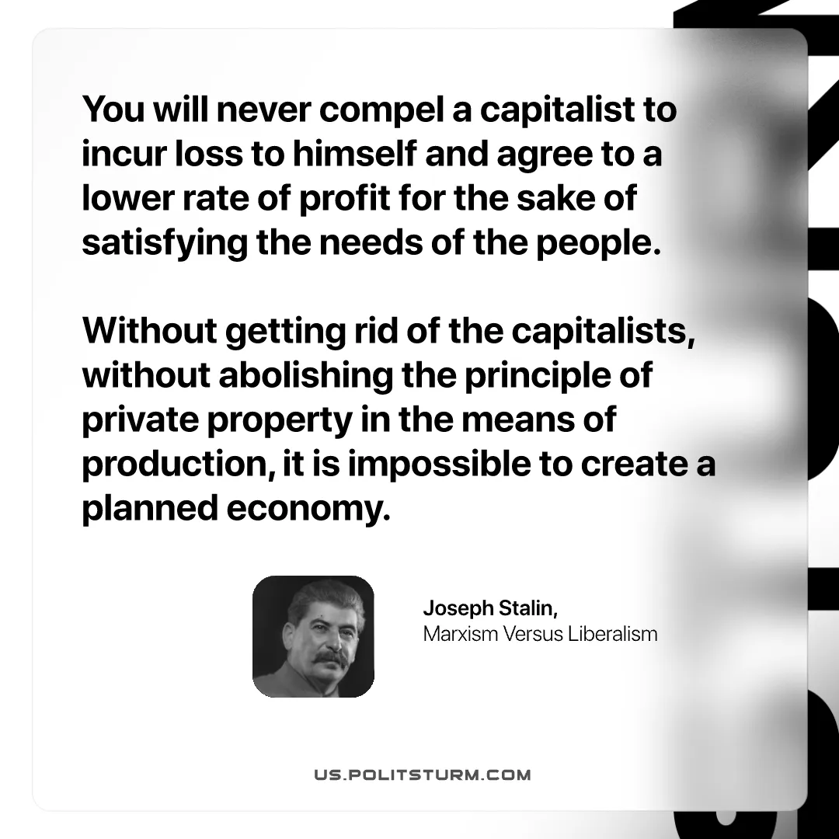

Original article
2025-09-25

“You will never compel a capitalist to incur loss to himself and agree to a lower rate of profit for the sake of satisfying the needs of the people. Without getting rid of the capitalists, without abolishing the principle of private property in the means of production, it is impossible to create a planned economy.”
Joseph Stalin, Marxism Versus Liberalism

Original article

