Lenin on What Makes a Social-Chauvinist
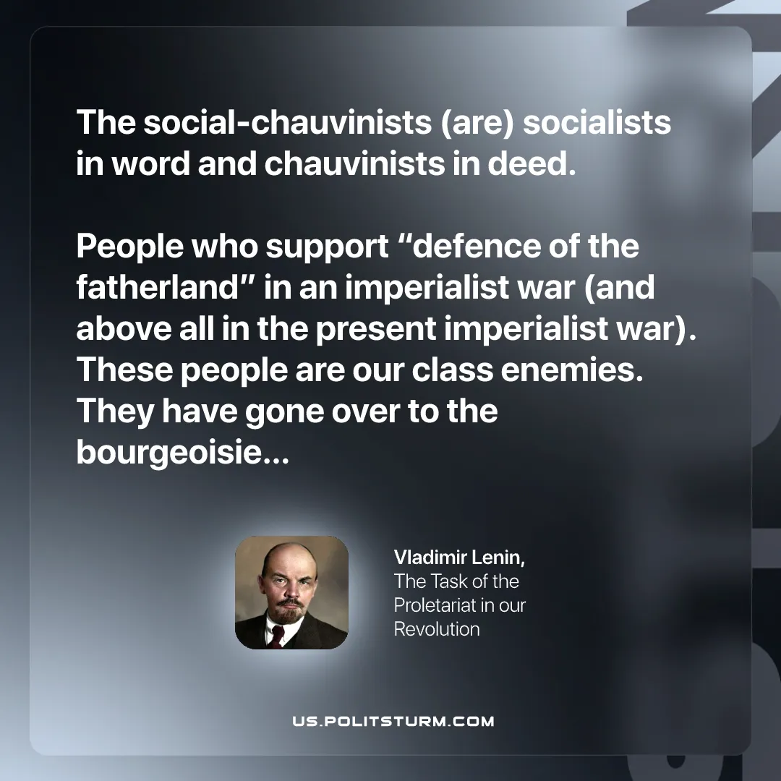

Original article
2025-09-18

“The social-chauvinists (are) socialists in word and chauvinists in deed. People who support “defence of the fatherland” in an imperialist war (and above all in the present imperialist war). These people are our class enemies. They have gone over to the bourgeoisie…”
Vladimir Lenin, The Task of the Proletariat in our Revolution

Original article

