Lenin on the Struggle for Democracy Fostering Communism
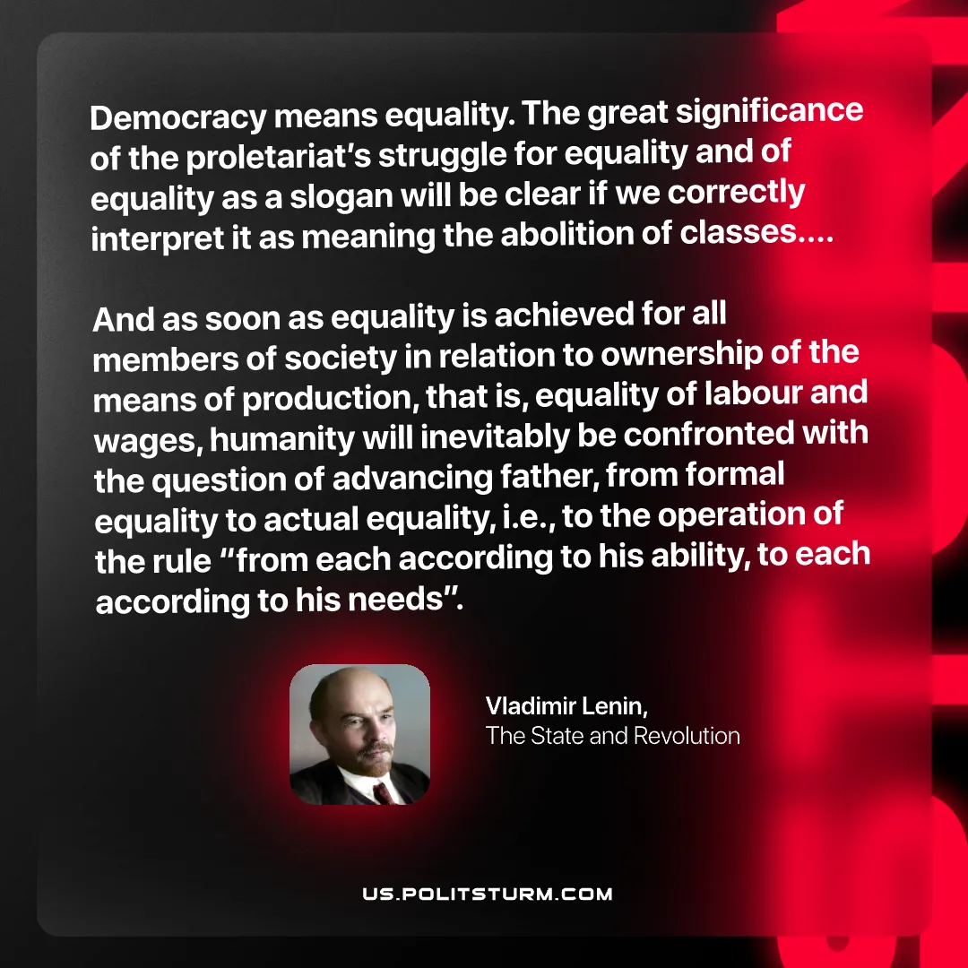

Original article
2025-09-07
1 min read

“Democracy means equality. The great significance of the proletariat’s struggle for equality and of equality as a slogan will be clear if we correctly interpret it as meaning the abolition of classes… And as soon as equality is achieved for all members of society in relation to ownership of the means of production, that is, equality of labour and wages, humanity will inevitably be confronted with the question of advancing father,
from formal equality to actual equality, i.e., to the operation of the rule “from each according to his ability, to each according to his needs”.”
Vladimir Lenin, The State and Revolution

Original article

