Stalin on the Choices Imperialism Provides
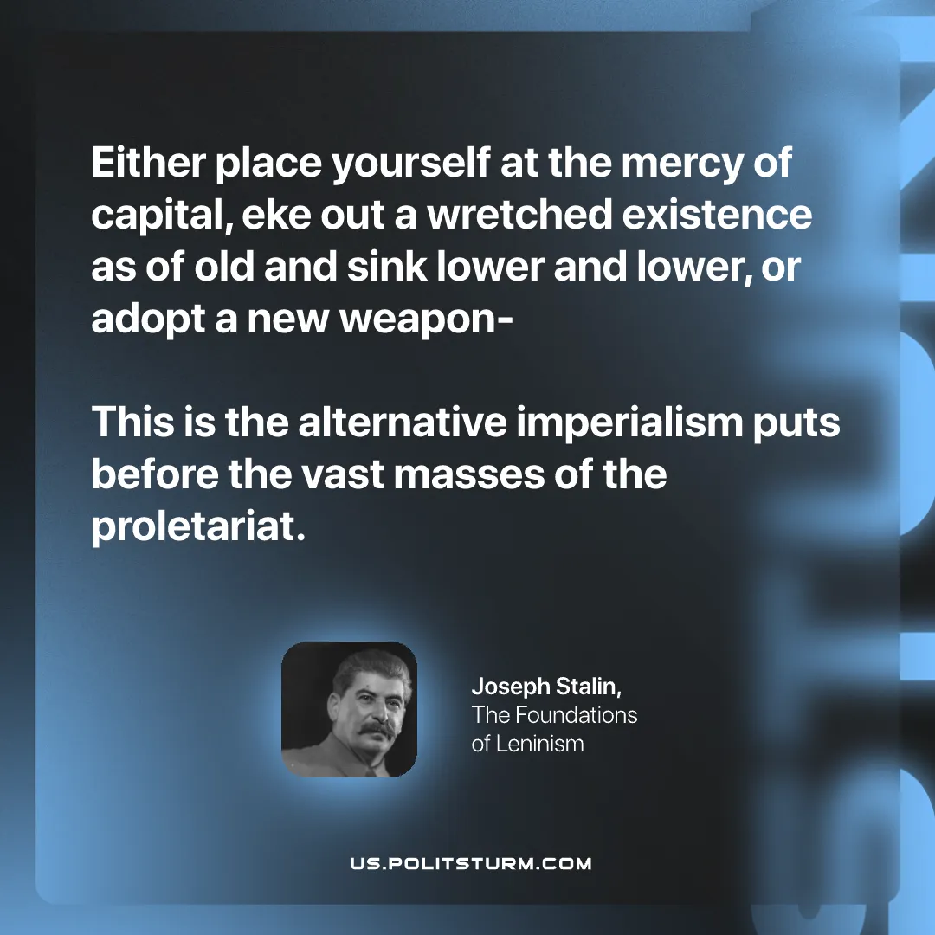

Original article
2025-08-30

"Either place yourself at the mercy of capital, eke out a wretched existence as of old and sink lower and lower, or adopt a new weapon-this is the alternative imperialism puts before the vast masses of the proletariat."
Joseph Stalin, The Foundations of Leninism

Original article

