Lenin on Capitalist Peace as a Deception
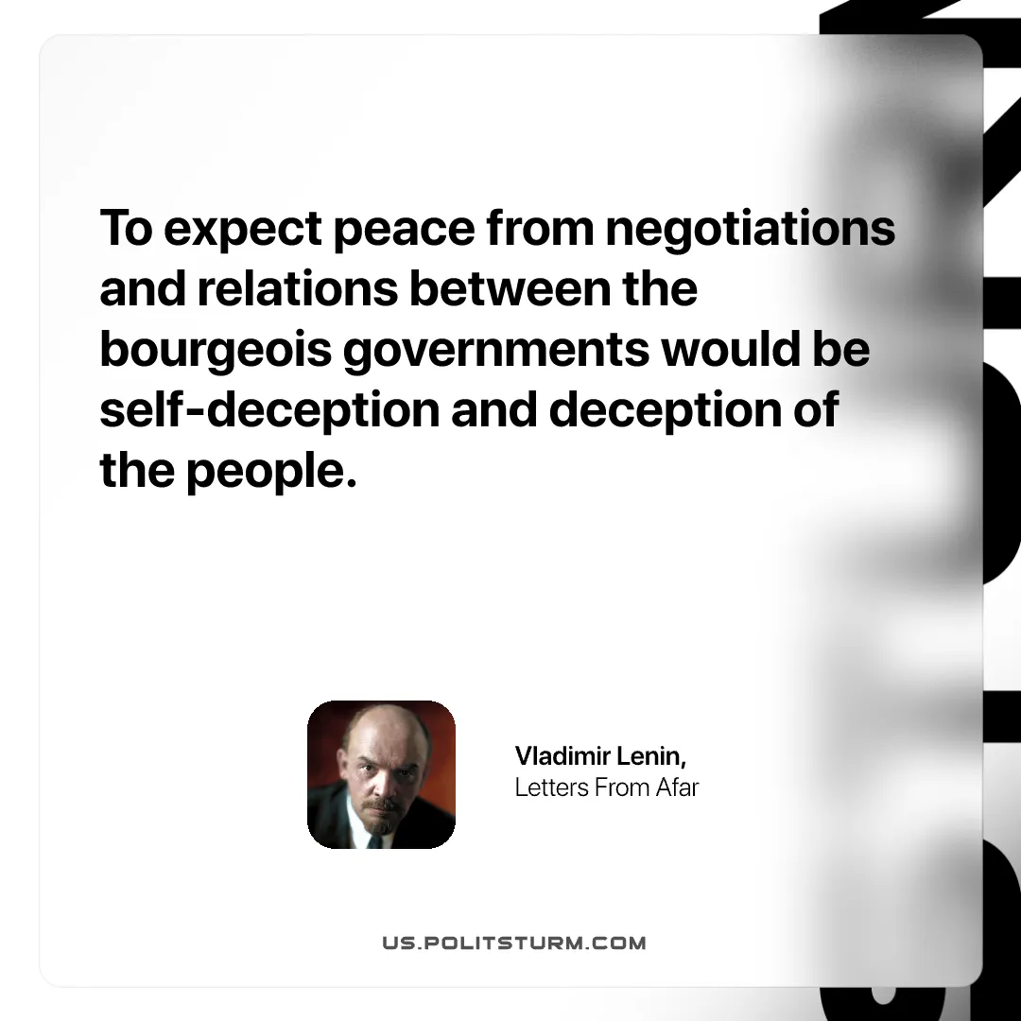

Original article
2025-08-17

“To expect peace from negotiations and relations between the bourgeois governments would be self-deception and deception of the people.”
Vladimir Lenin, Letters From Afar

Original article

