Lenin on Teaching the Masses to Distrust the Capitalists
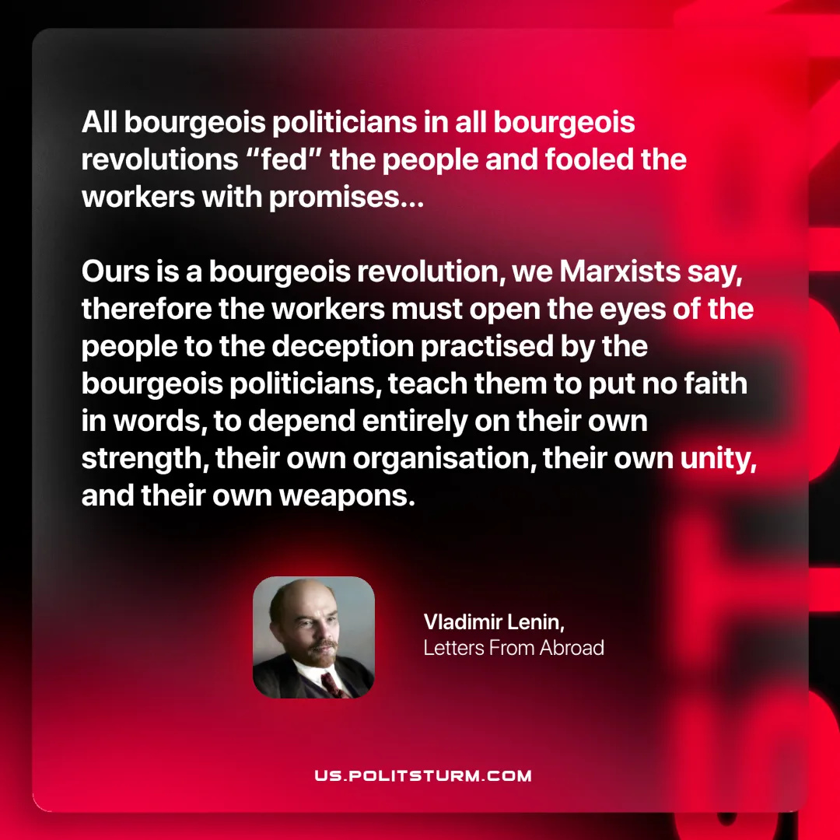

Original article
2025-08-03

“All bourgeois politicians in all bourgeois revolutions “fed” the people and fooled the workers with promises… Ours is a bourgeois revolution, we Marxists say, therefore the workers must open the eyes of the people to the deception practised by the bourgeois politicians, teach them to put no faith in words, to depend entirely on their own strength, their own organisation, their own unity, and their own weapons.”
Vladimir Lenin, Letters From Abroad

Original article

