Lenin on the "Centre"
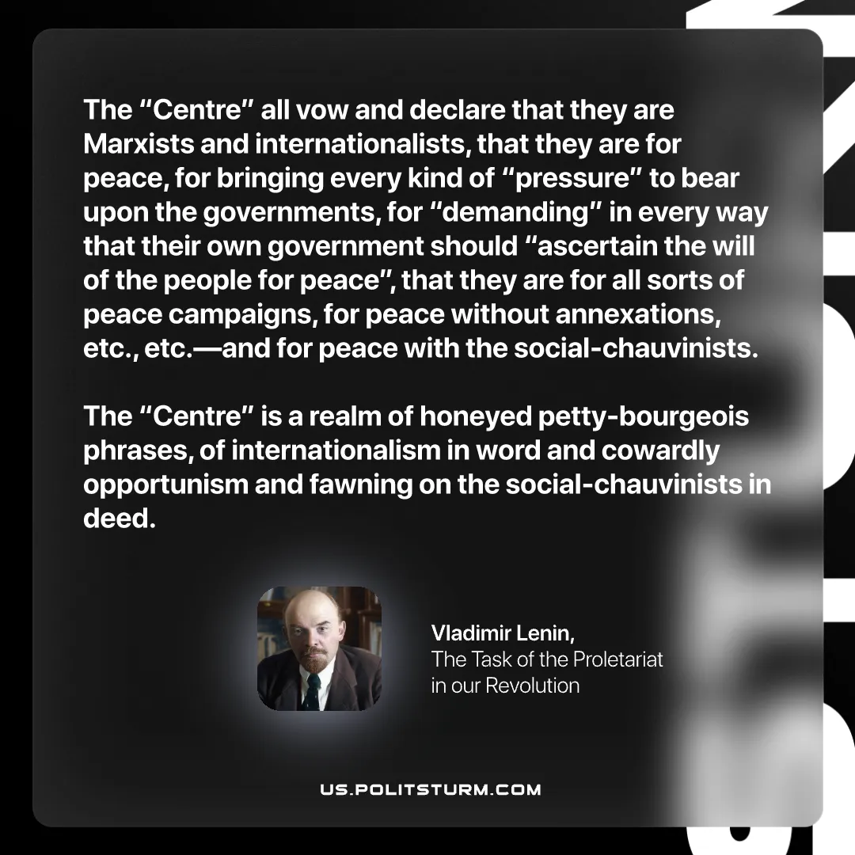

Original article
2025-08-09
1 min read

“The “Centre” all vow and declare that they are Marxists and internationalists, that they are for peace, for bringing every kind of “pressure” to bear upon the governments, for “demanding” in every way that their own government should “ascertain the will of the people for peace”, that they are for all sorts of peace campaigns, for peace without annexations, etc., etc.—and for peace with the social-chauvinists. The “Centre” is a realm of honeyed petty-bourgeois phrases, of internationalism in word and cowardly opportunism and fawning on the social-chauvinists in deed.”
Vladimir Lenin, The Task of the Proletariat in our Revolution

Original article

