Lenin on the Hypocrisy of Liberty of All Nations Under Capitalism
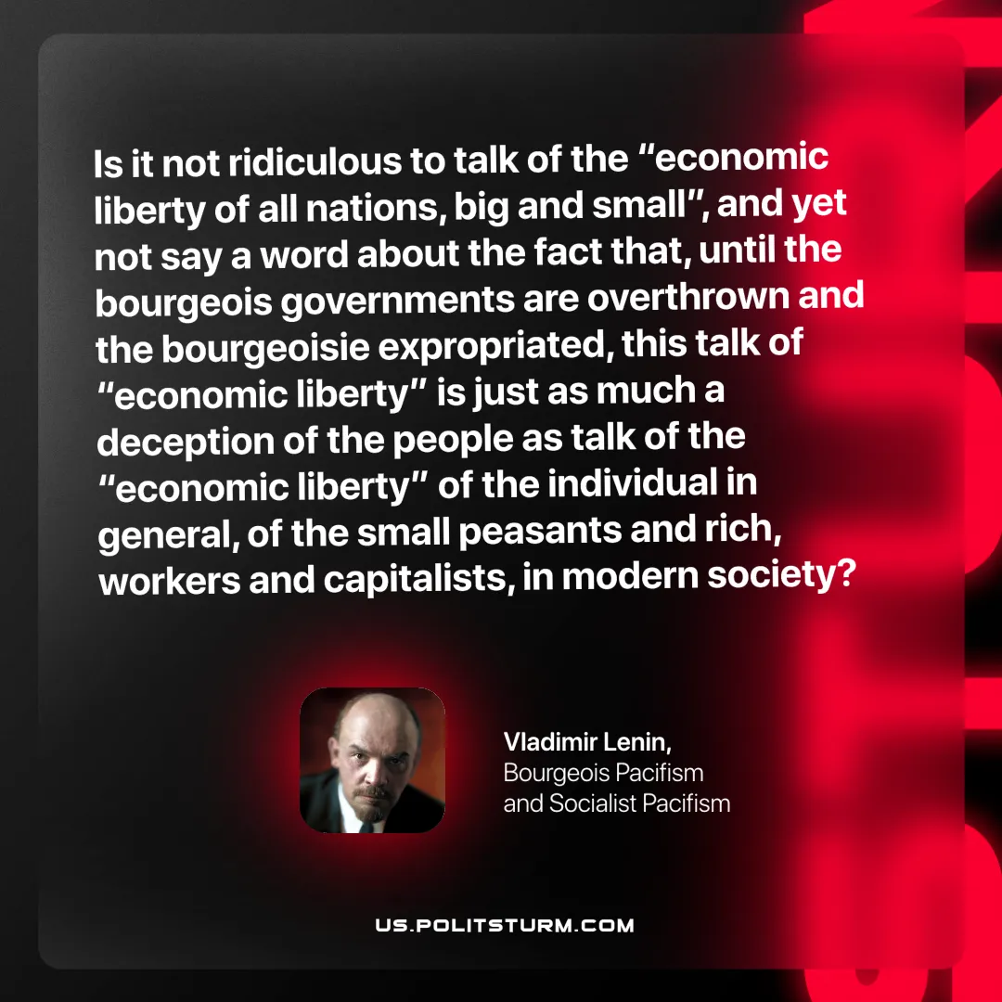

Original article
2025-08-02

“Is it not ridiculous to talk of the “economic liberty of all nations, big and small”, and yet not say a word about the fact that, until the bourgeois governments are overthrown and the bourgeoisie expropriated, this talk of “economic liberty” is just as much a deception of the people as talk of the “economic liberty” of the individual in general, of the small peasants and rich, workers and capitalists, in modern society?”
Vladimir Lenin, Bourgeois Pacifism and Socialist Pacifism

Original article

