Lenin on the Equal Rights of Nations
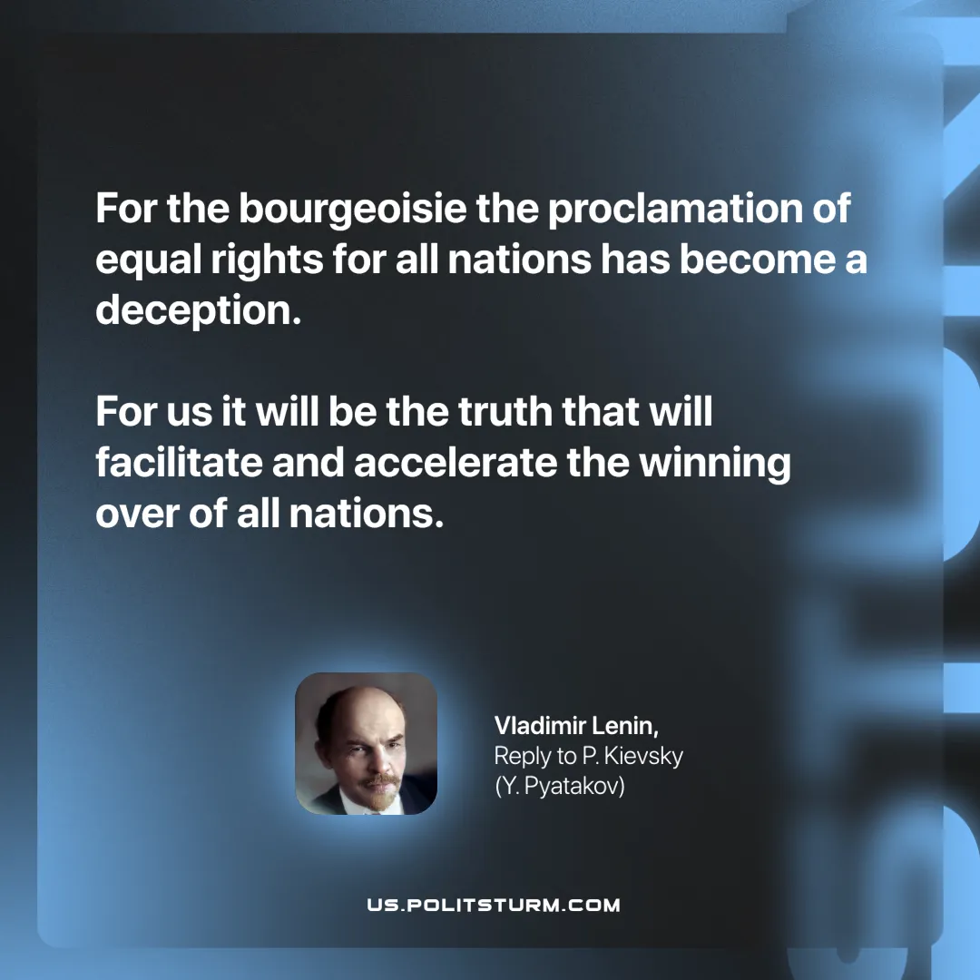

Original article
2025-07-24

“For the bourgeoisie the proclamation of equal rights for all nations has become a deception. For us it will be the truth that will facilitate and accelerate the winning over of all nations.”
Vladimir Lenin, Reply to P. Kievsky (Y. Pyatakov)

Original article

