Lenin on Demands for Disarmament
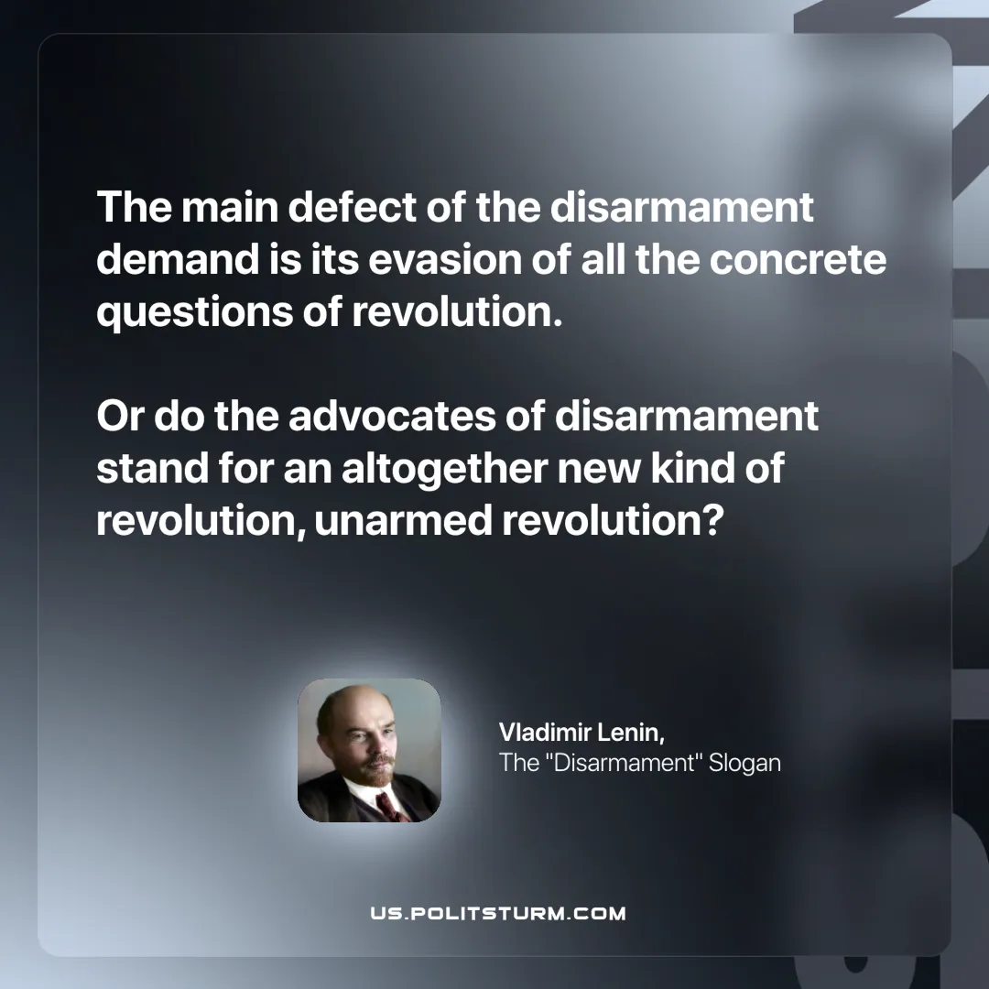

Original article
2025-07-05

“The main defect of the disarmament demand is its evasion of all the concrete questions of revolution. Or do the advocates of disarmament stand for an altogether new kind of revolution, unarmed revolution?”
Vladimir Lenin, The “Disarmament” Slogan

Original article

