Lenin on the Role of Socialists in Oppressed Nations
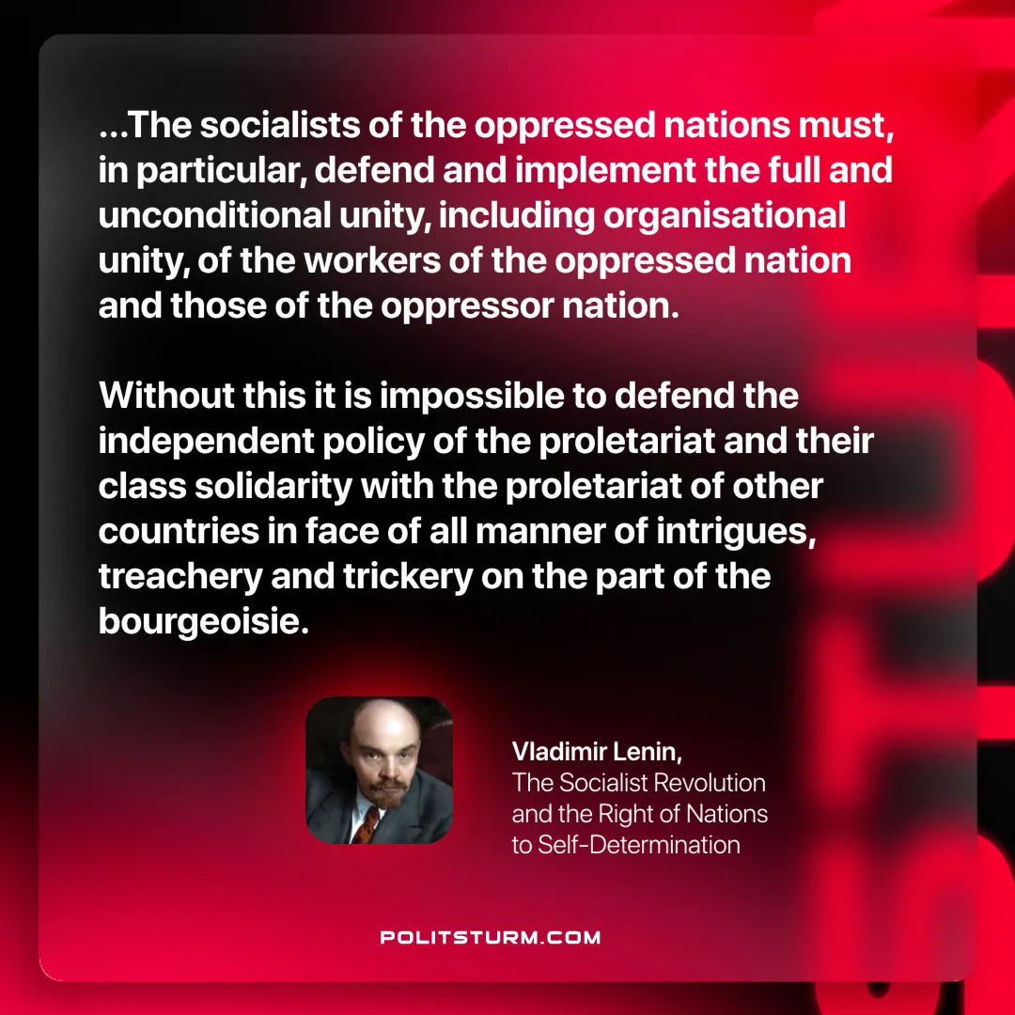

Original article
2025-05-06
1 min read

“...The socialists of the oppressed nations must, in particular, defend and implement the full and unconditional unity, including organisational unity, of the workers of the oppressed nation and those of the oppressor nation. Without this it is impossible to defend the independent policy of the proletariat and their class solidarity with the proletariat of other countries in face of all manner of intrigues, treachery and trickery on the part of the bourgeoisie.“
Vladimir Lenin, The Socialist Revolution and the Right of Nations to Self-Determination

Original article

