Lenin on Opportunists Pretending to be Marxists
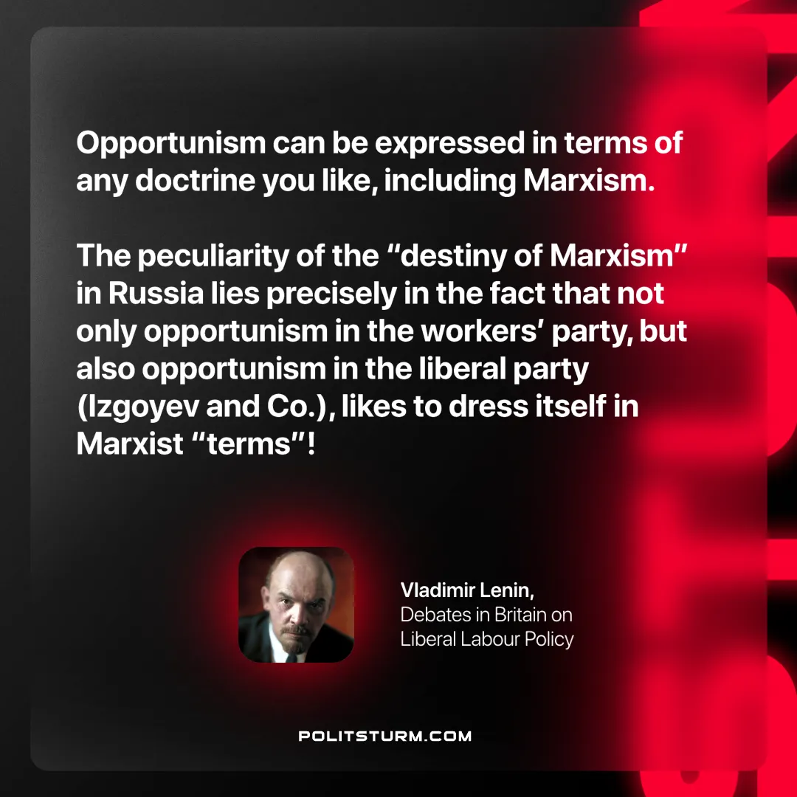

Original article
2025-02-23

"Opportunism can be expressed in terms of any doctrine you like, including Marxism. The peculiarity of the “destiny of Marxism” in Russia lies precisely in the fact that not only opportunism in the workers’ party, but also opportunism in the liberal party (Izgoyev and Co.), likes to dress itself in Marxist “terms”!"
Vladimir Lenin, Debates in Britain on Liberal Labour Policy

Original article

