United States and Iran Conflict Drags On
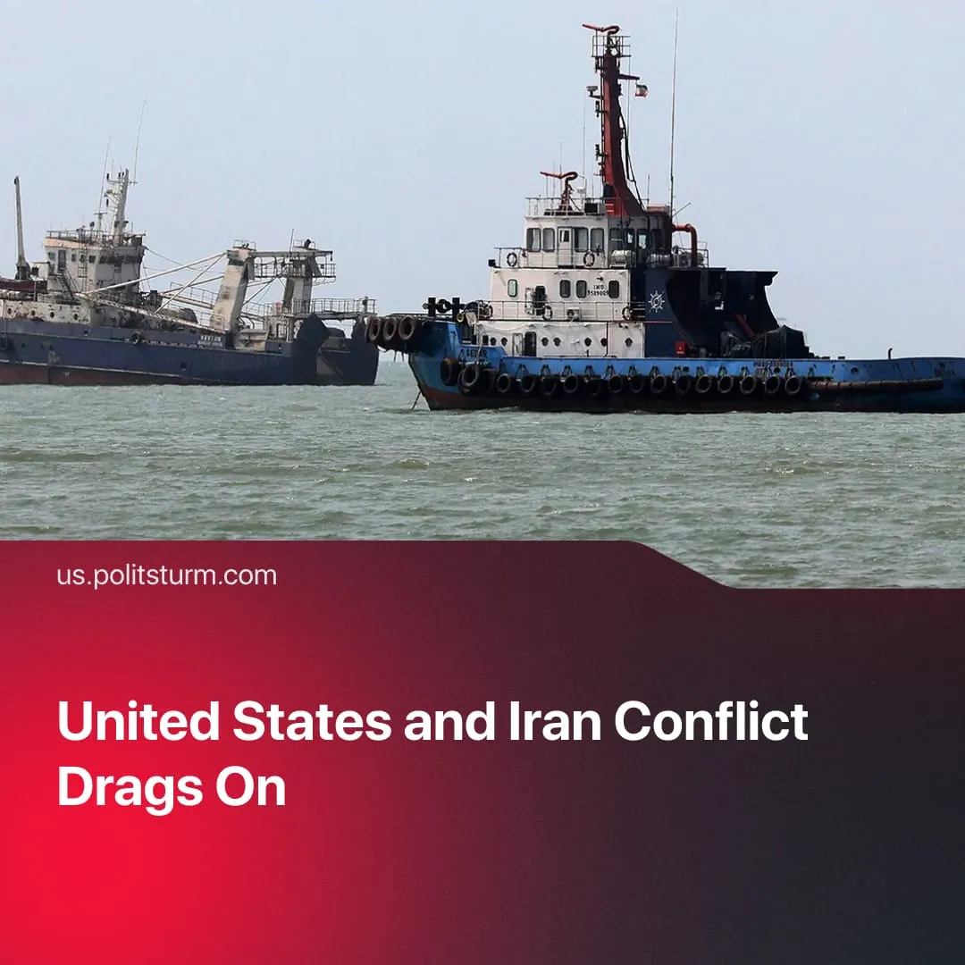

Original article
2026-08-29
2 min read

US becomes bogged down in its own “SMO” as 60-day ceasefire expires, negotiations stall, and Tehran claims it will now go on the offensive.
Details. The US-Iran interim Memorandum of Understanding (MoU) – which was signed on 17 June and provided for a 2 month ceasefire and further peace talks – officially expired, with officials acknowledging the diplomatic track has ended.
► US President Trump initially stated secret backchannels were still being used to contact Iranian leadership, but now denies that there are any ongoing talks. Trump ended his conciliatory rhetoric, stating that Iran will never make the "necessary" nuclear deal to end the conflict peacefully. The president escalated with claims that the Strait of Hormuz is American territory, and stated shipping damages will be paid using seized Iranian cash controlled by Washington.
► With direct bombing seemingly losing effectiveness, Washington recently shifted to economic warfare, with additional sanctions. The US Treasury announced it is "launching an economic onslaught against Iran's financial connections around the globe," threatening severe consequences against any country refusing to cut ties with Tehran. Iran warned that supporting American sanctions will be considered an act of war.
► The Iranian military announced a shift from a defensive strategy to a "fully offensive" posture, signalling increasing commitment to the conflict instead of diplomacy. Iranian officials warned all bases utilized by the American military are valid targets, and the IRGC are reportedly planning to strike NATO bases in Europe if the conflict escalates.
► Whilst the frequency of attacks from both sides has fallen since the MoU was signed, major strikes continue, and cargo traffic through Hormuz is still largely blocked despite claims of free passage. Middle East tensions are worsening as Gulf Arab states have launched strikes against Iran and broken economic ties. The Pentagon deployed an aircraft carrier to replace the previous one, as mounting American casualties now exceed 750 dead and wounded troops.
Context. This sits within a broader collapse of American diplomatic initiatives globally. In the Levant, despite Hamas signaling a willingness to disarm, Israel formally rejected the next phase of the Gaza peace plan and continued expanding operations into Lebanon. The European “SMO” conflict remains unresolved despite last year’s Trump-Putin Alaska summit.
► Trump originally negotiated the Memorandum of Understanding to pause hostilities, secure a diplomatic exit leaving the USA with a geopolitical advantage, and steer Iranian capitalists away from Chinese influence. However, the agreement rapidly collapsed in July over maritime passage disputes in the Strait of Hormuz, where renewed Iranian attacks on commercial tankers provoked massive American retaliatory airstrikes.
► The US initially echoed rhetoric mirroring the Russian “Special Military Operation”, selling the strikes as a quick, 4-week surgical intervention with limited objectives. Instead, the conflict has devolved into an open-ended conflict, lasting now 160+ days.
► Despite aggressive posturing, Iranian President Masoud Pezeshkian defended the expired memorandum as the best path out of the stalled conflict, demonstrating that Iran is also exhausted and that some regime elements still desire a diplomatic exit.

Original article

