Union Representation Petitions up 58% Through 2022
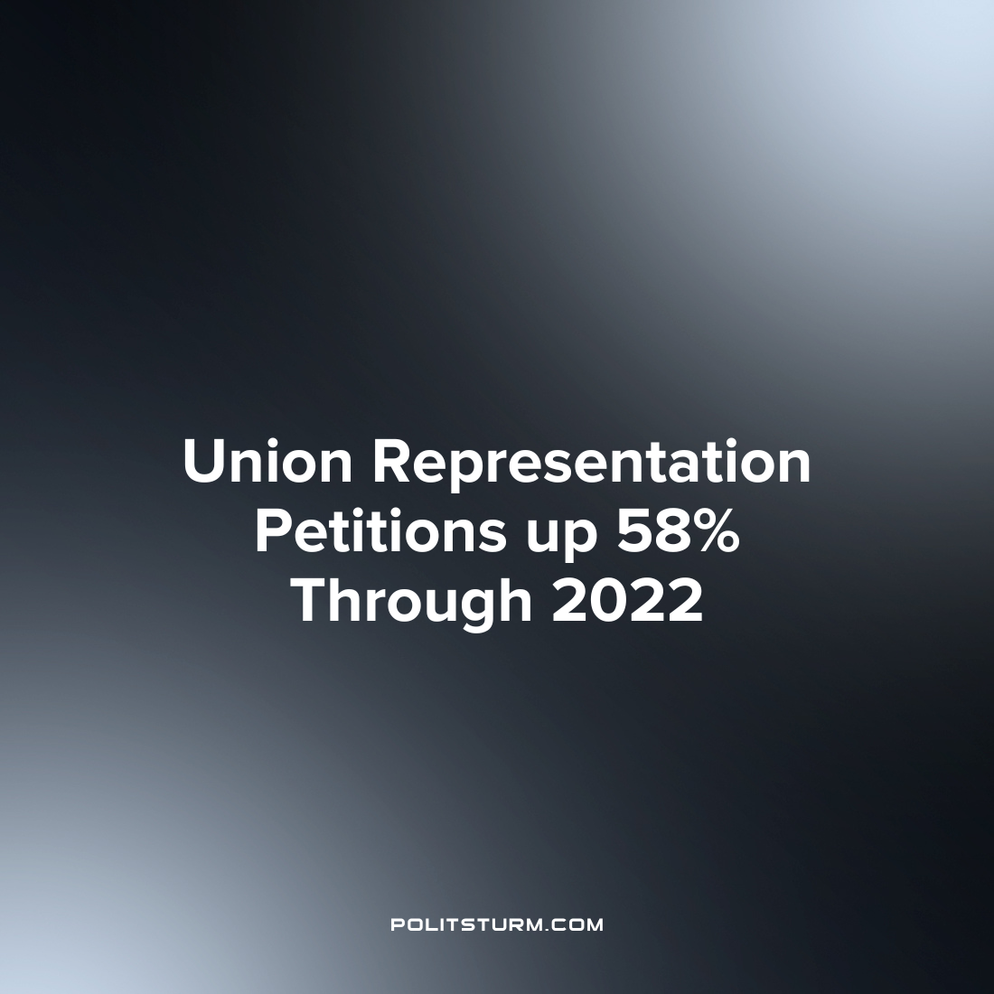

Original article
2022-08-26
1 min read

According to statistics released by the National Labor Relations Board union representation petitions in the United States are up 58% for the first three quarters of fiscal year 2022. 1,892 union representation petitions were filed so far through fiscal year 2022, compared to 1,197 over the same time period in the previous year. Union representation petitions are filed with the National Labor Relations Board to hold a vote for a union election.
The number of unfair labor practice charges has also increased over the same time period by 16%. These filings occur when there is a suspected violation of the National Labor Relations Act, which is subsequently investigated.
Unionization rates in the United States have been on a long-term decline. Back in 1983, 20% of U.S. workers were part of a labor union, and this figure has been nearly cut in half with only 10.3% of U.S. workers currently being union represented. While the increase of union petitions and filing may indicate that there is an uptick in labor organization activity, this must be viewed within the backdrop of historically declining unionization rates.
It is necessary that U.S. workers organize against the capitalists and struggle to improve working conditions. However, it is also imperative that workers understand Marxist-Leninist theory and apply it to the current labor struggle. Without Marxism-Leninist theory and practice, the labor union movement will not have the militancy and tactics to overcome the exploitation of the capitalist class and end the exploitation of man by man.
Sources: 1 2

Original article

