Unemployment Crisis in India
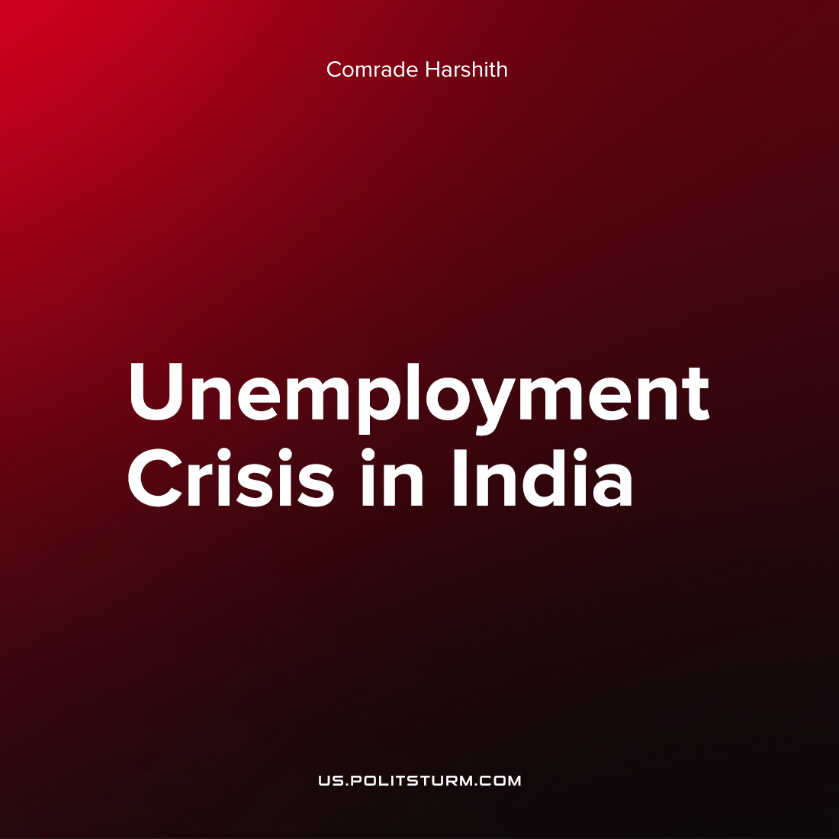

Original article
2022-12-12
5 min read

One of the biggest economic problems facing the people of 21st century India has been unemployment. However, within the last 6 months, tech firms in the service sector in India have fired over 50,000 employees.
When the Covid-19 pandemic disrupted the world's economy, many tech companies saw huge increases in their rate of profit. This was not without material basis. As more of our day-to-day activity came to be mediated through the internet, tech firms went into a so-called “pandemic boom” phase. In this phase, they took on large numbers of employees (for much lower pay than usual) to meet the rising demand for tech services across all fields. These companies include Amazon, Twitter, Unacademy & Byjus (EduTech firms), Meta, and so on. One important reason for the hiring of large numbers of Indian workers specifically has been the increasing competitiveness of the Indian labor market over that of China or Vietnam where wages have risen and industries diversified over the last 2 decades.
Within a few months of this hiring boom, Covid restrictions began to be relaxed after the failure of the state in being able to effectively maintain them. As people started returning to “normal”, in-person ways of living, these excess digital infrastructure jobs became redundant as the demand for online services suddenly decreased.
Let us consider the case of Byju’s an 'Edu-Tech' firm whose value surged during the pandemic, and forming a bubble which soon burst. In very basic terms, a bubble occurs when the value of a company is over-evaluated beyond its real value, typically due to speculations that arises from increased investment. The bubble bursts when the value of the company has been so over-evaluated that it is unsustainable with the real-value of the company’s assets.
Alongside speculative bubbles in the tech industry, inflationary spikes in the global economy and the subsequent raising of interest rates have affected tech industry investments which heavily rely on credit. The Reserve Bank of India (RBI) raised its interest rates to counter-balance the inflationary pressures arising from supply chain disruptions. This hike in interest rates has caused a fall in lending to the Tech industry, and to the investments in Unicorn Startups in India’s service sector (which contributes the most to India’s GDP).
The result of these combined economic pressures has been the “layoffs season”. Over the last 6 months, the aforementioned Tech companies have fired nearly 60,000 employees with very short notices. To get a glimpse of India’s unemployment situation, we will look at a few statistics:
(1) The CMIE (Centre fir Monitoring the Indian Economy) reported in FYI 2021-22 that the unemployment rate had reached 6.9%.
(2) Among females, the rate has reached nearly 10%.
(3) In the group of new graduates, the rate is 3 times the average.
However, alongside the sharp decline in jobs and rise in prices, GDP growth in India has been very strong, at 8.9% (compared to the IMF global average of 3.6%) in 2021-22. Now what a fantastic contradiction this is! On the one had, we are told that we have an extraordinary growth of the GDP, and on the other hand, there is rampant unemployment.
This is a fundamental contradiction within capitalism, combined with the effects of imperialism. Let us explain.
Even 'Neoclassical' economics accepts this contradiction (however it fetishizes it to a large extent) in capitalism. The Phillip’s Curve represents the inverse relation between inflation and unemployment.
Higher Inflation → Lower Unemployment
Lower Inflation → Higher Unemployment
What’s the logic? The global response to inflationary pressures have resulted in the hike in the interest rates which have crippled the ability of the firms to borrow for investment, forcing them to cut the corners and “become more competitive” (as the CEO of Byju’s Mr. Raveendran put it). The block of credit inflow and the bursting of the Tech bubble have resulted in the layoffs of employees in the tens of thousands to “reduce redundancies”, and “adjust themselves to the evolving market conditions”. As a result, thousands of people have been pushed to the verge of financial collapse and several families are facing crises.
This is a contradiction that capitalism cannot solve, meaning, the working-class suffering is two-fold: either suffer high inflation, or when that lowers, suffer unemployment. This contradiction. The very fact that you can have a positive GDP growth with rising unemployment (rising poverty for the masses) reveals the true nature of a capitalist economy. That aside, it would be worthwhile to point out now, the Soviet Union had no unemployment or inflation in its history, except for the last 2-3 years. Capitalism requires both inflation and unemployment to function.
(Economists opine that a moderate level of inflation is in fact, efficient. If you knew that prices would have risen tomorrow in comparison to today, you would spend it now instead of tomorrow, stimulating demand and increasing short-term profit on capital; of course, as always, such economic analyses don’t even care to recognize that poor people exist)
Let us now look what the Indian government has been doing about all this:
In 1991, when India “liberalized” its economy under pressure from the IMF, the share of the industrial sector in the economy fell from 27.3% to roughly 20%. This was a (relative) de-industrialization of India. The service sector (which has a relatively low employment potential) came to dominate the sectoral composition of Indian economy, and India has had to import most of its capital goods from the Imperial Core. Much of the growth India has experienced in the decades since 1991 have come primarily from the services sector. This reliance on services has had a crippling effect on the Indian Economy – as a direct result of the imperialization of India. The effects are worse in neighboring Pakistan.
The Indian working class has suffered a lot in the last 6 years from a combined effect of rising inflation, employability crisis and negligible government spending in education and healthcare. On the contrary, there has been a consistent policy of disinvestment & privatization. In other words, the response of the government has been more neoliberalism – “production and sales linked incentives to promote the Ease of Doing Business”, which, in reality translate to subsidies on capital investments and scrapping labour protections (refer New Labour code bill, India, 2019). It will not be long before these schemes to ‘attract capital’ turn into an additional burden for the working class.
The CMIE has reported (in its latest report) that India currently has nearly 31 million unemployed people (out of a population of 1.2 Billion), and this number is only expected to surge as the Ukraine conflict drags on and US Federal Reserve continues to destabilise global interest rates through unilateral interventions.
One thing is clear, however, that capitalism by its very design, by placing profits over people, cannot solve the problem of either inflation or unemployment. Only a socialist system which guarantees employment can defeat this affliction. It is precisely to prevent such a system being established that we see a rising fascist political atmosphere, with a sharp increase in divisive identity politics in terms of religion, caste, ethnicity and language. The increasingly reactionary Indian government will do anything in its power to maintain this status quo.
Sources: 1, 2, 3, 4, 5, 6, 7, 8, 9

Original article

