Unemployment Claims Spike to 6.6 Million
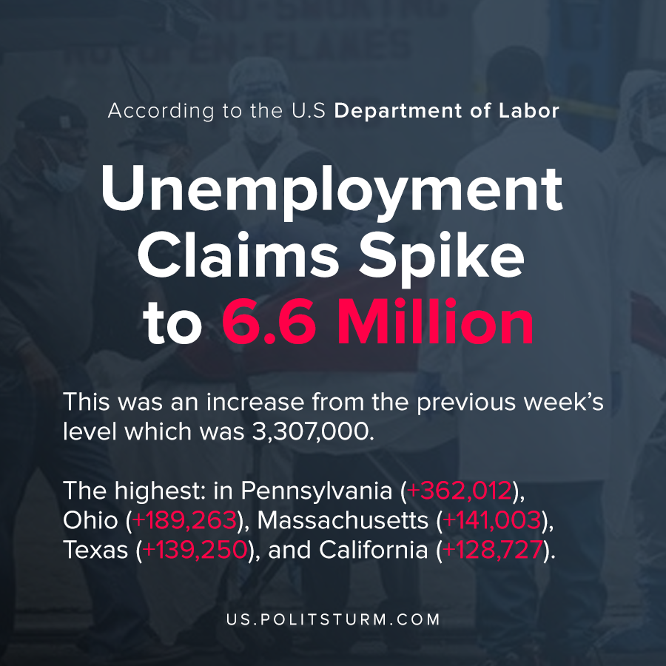

Original article
2020-04-03
1 min read

According to the latest release from the U.S Department of Labor, unemployment claims spiked to 6,648,000 in the week ending March 28. This was an increase from the previous week’s level which was 3,307,000.
Initial claims for unemployment spiked the highest in Pennsylvania (+362,012), Ohio (+189,263), Massachusetts (+141,003), Texas (+139,250), and California (+128,727). The release contained a disclosure citing the COVID-19 impact as a major cause of the increased unemployment claims and its impact on economic activity.
The new surge in initial unemployment claims indicates that unemployment will be increasing at a rapid pace. Workers who are unable to work through no fault of their own are forced to apply for any unemployment assistance available to them, if any.
Under the current conditions with a national health crisis and simultaneous economic crisis, the capitalist system puts the brunt of the negative repercussions on the working class. While unemployment is categorically negative from the worker’s perspective, for the capitalist’s perspective it increases the reserve army of the unemployed.
The capitalist system is ill-equipped to handle both the Coronavirus public health catastrophe, as well as the recurrent economic crises brought about by capitalist relations of production. Unlike a planned socialist economy, capitalism is subject to periodic crises that irrationally destroys productive capacity and creates millions of unemployed workers to produce profits for a small group of oligarchs. The solution to this problem is the dismantling of capitalist relations of production, and the building of a planned socialist economy for interests of the working class.

Original article

