UN Resolutions on Gaza and Israel Have Changed Nothing
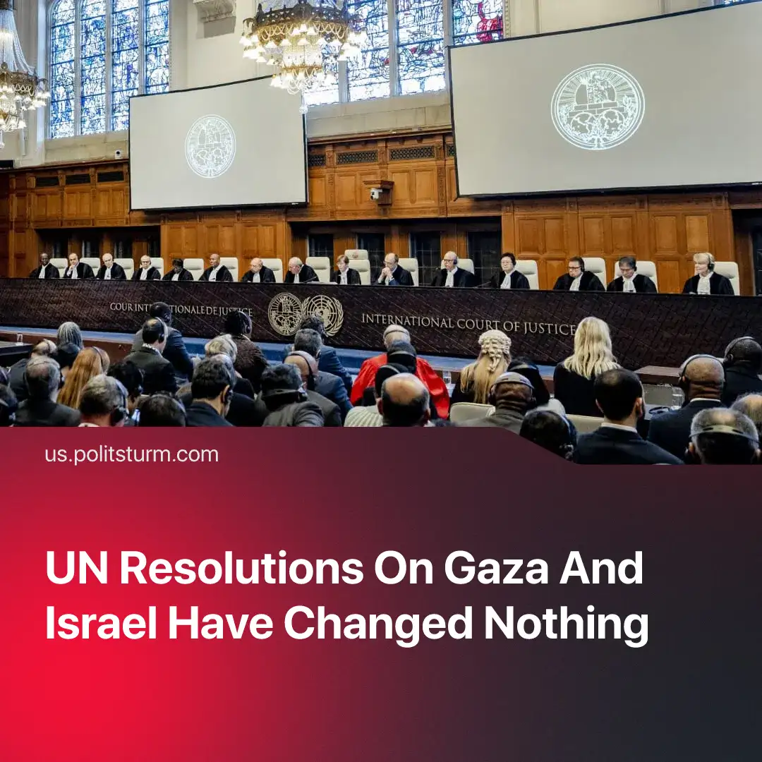

Original article
2025-09-22
1 min read

The UN's decision on Israel is unlikely to change the situation in Gaza.
Details. The UN Commission of Inquiry, the organisation’s permanent fact-finding body, stated that Israel is plausibly committing genocide in Gaza. However, like the ICJ and ICC, it lacks enforcement power, as all depend on state cooperation.
► Israel has launched an operation to seize Gaza City and eventually the entire strip. Israeli officials have framed this as an effort to “destroy Hamas” and “secure hostages”.
► Since genocide is harder to prosecute than other war crimes — requiring proof of intent — major imperialist states are unlikely to agree on the issue, leaving the UN to merely issue formal statements. Following the finding, the US once again vetoed a UN ceasefire resolution.
Context. Over the past three years, massive global protests, repeated UN votes, and even the ICJ’s charges against Netanyahu and Hamas officials have had a negligible effect on the conflict. These “historic” rulings and declarations have been reduced to meaningless statements, openly ignored by major powers whenever they conflict with imperialist interests.
► These events highlight the provocative nature of Hamas’s October 7 attack, driven by internal factional struggles and to advance the interests of reactionary Iran, which sponsored the attack. Hamas has exposed millions of lives to the attacks of Netanyahu's nationalist regime, fully justifying Israel's decades-long support for Islamic fundamentalists. Read more about the ties between Israel and Hamas in our in-depth article.

Original article

