The UN is Powerless Against the Redivision of the World
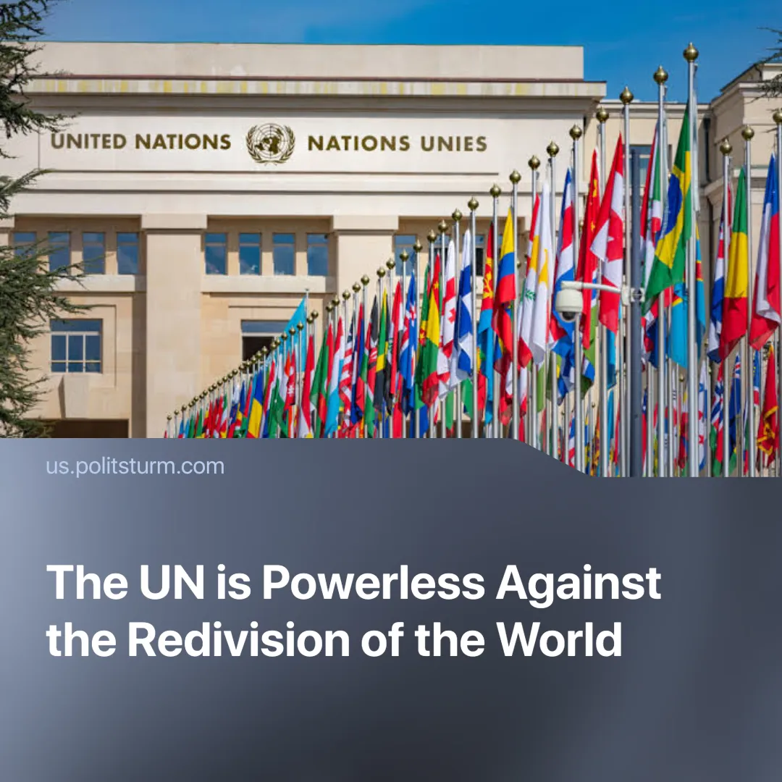

Original article
2025-06-27
1 min read

The UN is increasingly becoming merely a formal organisation. Appeals for de-escalation between Iran and Israel were ignored due to contradicting imperialist interests.
Details. Before the US strikes, the UN Secretary-General, António Guterres, warned that an expansion of the conflict would “ignite a fire no one can control” and called on all parties to “give peace a chance”, urging diplomacy and restraint.
► The head of the UN-associated International Atomic Energy Agency (IAEA), Rafael Grossi, said that military escalation increases "the chance of a radiological release with serious consequences for people and the environment," and called for “maximum restraint.”
► After the “successful” US strikes on Iranian nuclear sites, a ceasefire between Israel and Iran was secured with Qatar’s involvement. None of the imperialist powers were in a position to risk further escalation, despite growing contradictions. Tensions continue to develop, with Iran leaving the IAEA – potentially to pursue nuclear weapons unrestricted.
Context. The UN’s predecessor, the League of Nations, was set up after World War I as the first international organisation dedicated to preserving peace through collective security and diplomacy. It was dissolved after it failed to prevent World War 2, and its functions were transferred to the UN.
Important to Know. Today, the UN plays a role similar to the League of Nations before WWII. Composed of capitalist states, its liberal worldview prevents it from understanding the material roots of conflict, nor does it have any interest to. This produces empty moral proclamations without real action, as seen from its positions on climate change to genocide in Gaza
► For example, in 1935, the League of Nations condemned Italy’s invasion of Ethiopia and imposed limited sanctions, but these were ignored by major powers, and Italy proceeded with its conquest unimpeded. Likewise, UN appeals for de-escalation between Iran and Israel were ignored due to conflicting imperialist interests.
► As imperialist contradictions intensify, the economic interests of the great powers demand a redivision of spheres of influence, rendering appeals for peace meaningless. Like the League of Nations, the UN is destined to a similar fate under the pressures of an approaching intra-imperialist world war.

Original article

