UN Meets for 80th Anniversary
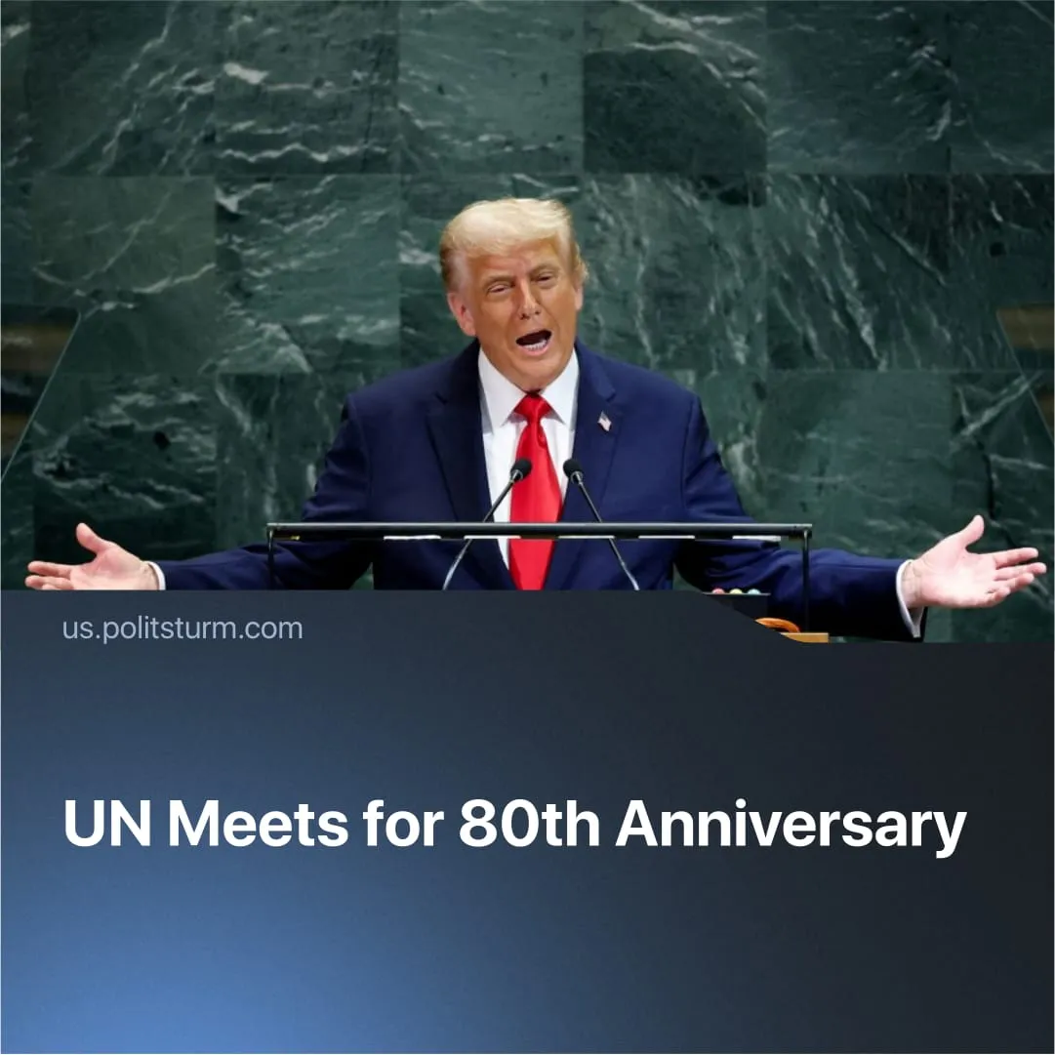

Original article
2025-10-04
2 min read

At the UN’s 80th meeting, China called for multipolarity, Trump mocked the UN’s purpose, and deep contradictions between leaders were evident.
Details. The Assembly opened under the theme “Better together” and the UN80 Initiative, which aims to cut overlapping mandates and costs. A 20% staff cut was announced after funding shortfalls.
► Donald Trump used his address to dismiss the UN as “nothing more than empty rhetoric,” bluntly asking, “What is the purpose of the United Nations?” He claimed EU migration was a “flood destroying Europe’s culture.” On climate, he rejected deals as a “globalist hoax,” insisting, “America will not cripple its industry for fantasies of climate hysteria.”
► China’s Foreign Minister Wang Yi focused on “true multilateralism”, which he said was a rejection of “rules made by a handful of powers” in favour of “equal rights for all nations.” He stressed that “no country has the right to impose its will” and linked this vision to empowering the Global South and reforming global governance.
► Debates over reform of the Security Council — the UN’s top body with five permanent veto powers (US, UK, France, Russia, China) — continued, with smaller nations pushing to add new permanent members.
► Divergences among leaders were stark. Trump denied climate change entirely, while Brazilian president Lula warned that “the climate crisis is the greatest threat to humanity’s survival.” In another incident, Iranian president Masoud Pezeshkian condemned the Israeli offensive in Gaza as “state terrorism,” while Israel defended it as “self-defence” and rebuked states recognising a Palestinian state.
Context. This UN meeting takes place against the backdrop of growing global economic crisis and conflicts. Last year saw the most conflicts since World War II, exposing the UN’s powerlessness to secure “world peace.
► The Security Council has become paralysed by vetoes. The US repeatedly blocks resolutions on Palestine, shielding Israel’s offensive in Gaza; Russia blocks condemnations of the SMO.
► Additionally, its other international goals have failed. Global poverty reduction has stalled — nearly 700 million people still live in “extreme poverty”, progress has stalled, and inequality is growing. On climate, the UN pledged to keep warming below 1.5 °C, yet the world is on track for ~2.7 °C of warming by 2100.
Important to Know. The different positions expressed in the speeches are representative of different blocs of imperialist current interests.
► China’s multipolar rhetoric is aimed at undermining US hegemony and expanding its own imperialist influence by appealing to nations looking for an alternative to Western imperialism. However, its “partnerships” subordinate economies. In 2023, China accounted for about a third of Russia’s imports, while Russian exports to China — overwhelmingly discounted fossil fuels and raw materials — made up roughly 6% of China’s total imports.
► Trump’s attacks on the UN aim to strip it of any authority to constrain US imperialism, while claiming credit for “solving wars” outside its framework. By cutting funding, quitting agencies, and denouncing resolutions, Washington ensures the UN cannot check its military, economic, or geopolitical interventions — preserving hegemony and freedom of action.
► Additionally, Trump has worked to fracture Europe, keeping it divided and dependent as a subordinate market. His UN speech focusing on European migration aligns with broader efforts to bolster far-right, anti-EU parties and prevent Europe from acting as an independent bloc.
► The UN is powerless because monopoly capitalism produces conflicts that no international institution can resolve. Rivalries over markets, raw materials, and spheres of influence force wars, making “peace” merely an instrument of imperialist management. Just as the League of Nations collapsed, the UN is on the same track, with its statements and goals appearing increasingly hollow.

Original article

