UN Issues Climate Warning
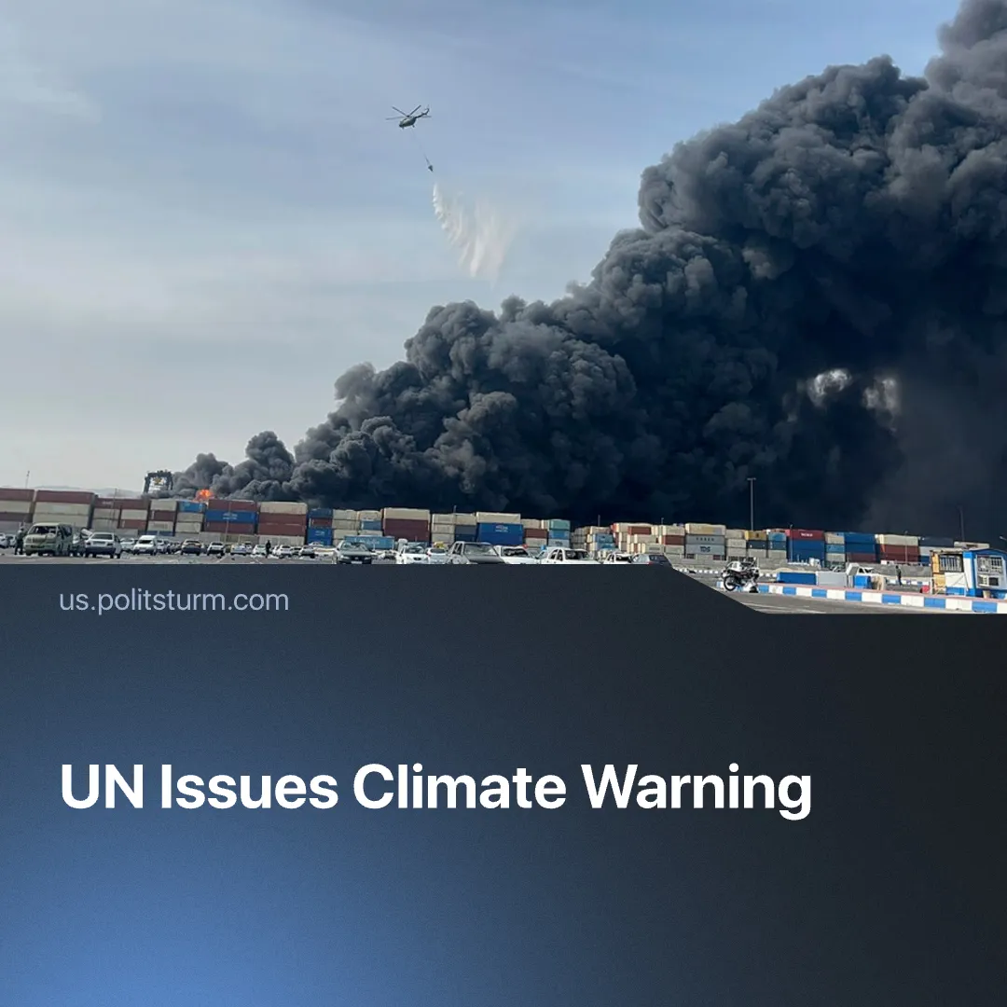

Original article
2026-04-02
1 min read

Despite UN warnings of unprecedented climate imbalance in 2026, it has repeatedly proved impotent to stop a crisis driven by capitalist production.
Details. The UN recently issued a warning, stating that the Earth is now facing an unprecedented climate imbalance. Record levels of accumulated heat in the climate system, measured in 2025, indicate that the severity and frequency of extreme weather events will continue to intensify throughout the 2025–2029 period.
► The UN’s World Meteorological Organization reports that the last 11 years have been the warmest on record. Additionally, Arctic sea ice is projected to reach record-low levels in 2026. Global temperatures are expected to rise further due to intensifying El Niño, a natural climate pattern that increases oceanic and atmospheric temperatures in the Pacific.
Context. The UN is unable to compel capitalists to take measures that would meaningfully protect the climate at the expense of profit. Instead, capitalists have sought to profit from the crisis rather than resolve it.
► The UN was further weakened by the United States’ withdrawal from dozens of international organisations in early 2026. As a result, the UN lost thousands of climate specialists and has experienced significant budget cuts.
► Increasing militarisation and the cost-of-living crisis have distracted public attention from the worsening climate catastrophe. In 2021, the majority of the UK public had supported accelerated net zero emissions goals, but now, only less than one third consider this necessary.
► Water scarcity is rising in multiple regions of the world, especially in countries like Iraq, which is expecting its driest year on record since 1933. Devastation and fuel consumption caused by imperialist military operations also destabilise the climate – in just 14 days of US bombings of Iran, 5 million tons of CO₂ were emitted into the atmosphere.
► In contrast to capitalist inability to address climate change, the historical experience of the Soviet Union demonstrates that a socialist planned economy is uniquely capable carry out large-scale environmental protection alongside rapid industrial development.

Original article

