UN Decries Amazon, Walmart, and DoorDash for Awful Wages and Union-busting
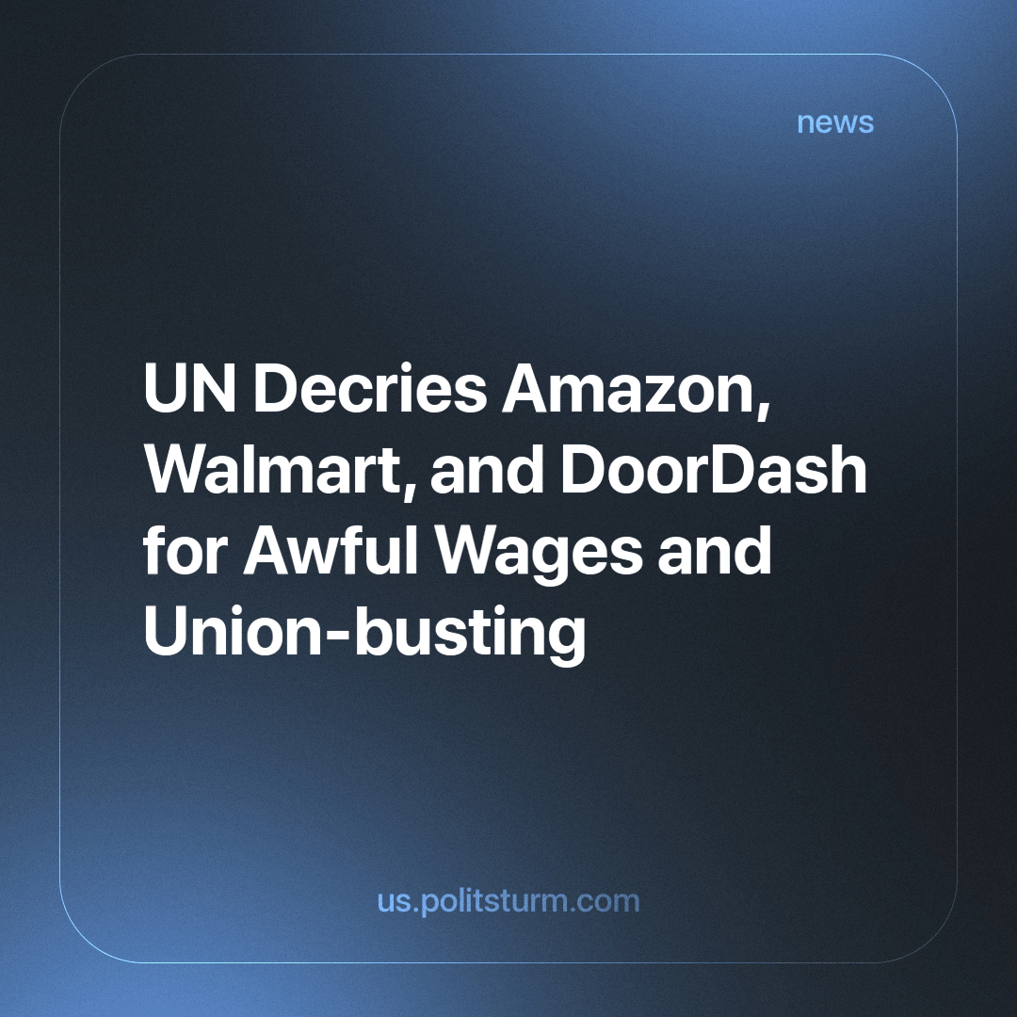

Original article
2023-11-09
1 min read

The UN special rapporteur on extreme poverty and human rights has called on the CEOs of Amazon, Walmart, DoorDash, and the US government to address allegations that top US corporations pay such low wages that they trap workers in poverty, forcing them to rely on government assistance programs to survive.
In the documents released by the United Nations they found that these corporations had paid a starving wage and subpar conditions which include the following, “The concerns apply to many workers in the US, which relates to how the minimum wage is set in legislation, whether at federal or state level, wage theft by employers, unpredictable yet inflexible working schedules, the sake of undocumented workers, violation of union rights, and automation, these are the most important issues that apply across the workforce in the US.”
The violations against workers have been a constant thread since the formation of these companies, and are not the worst things these 3 companies have done before. Amazon famously made workers work so hard they had to pee in bottles to maintain output. Walmart also has a reputation for exploiting workers in the dependent states to make the cheapest clothing.
These concerns have been a reality across the entirety of the working class. The capitalists exploit the workers to make profits. Therefore, it is logical that the largest capitalists are the best exploiters and will force the working class into the worst position while maintaining maximum profits.
It is pivotal that the working class rises against the profiteering and exploiting capitalists and their continued oppression.
Sources 1

Original article

