Human Trafficking of Ukrainians Increases in the EU
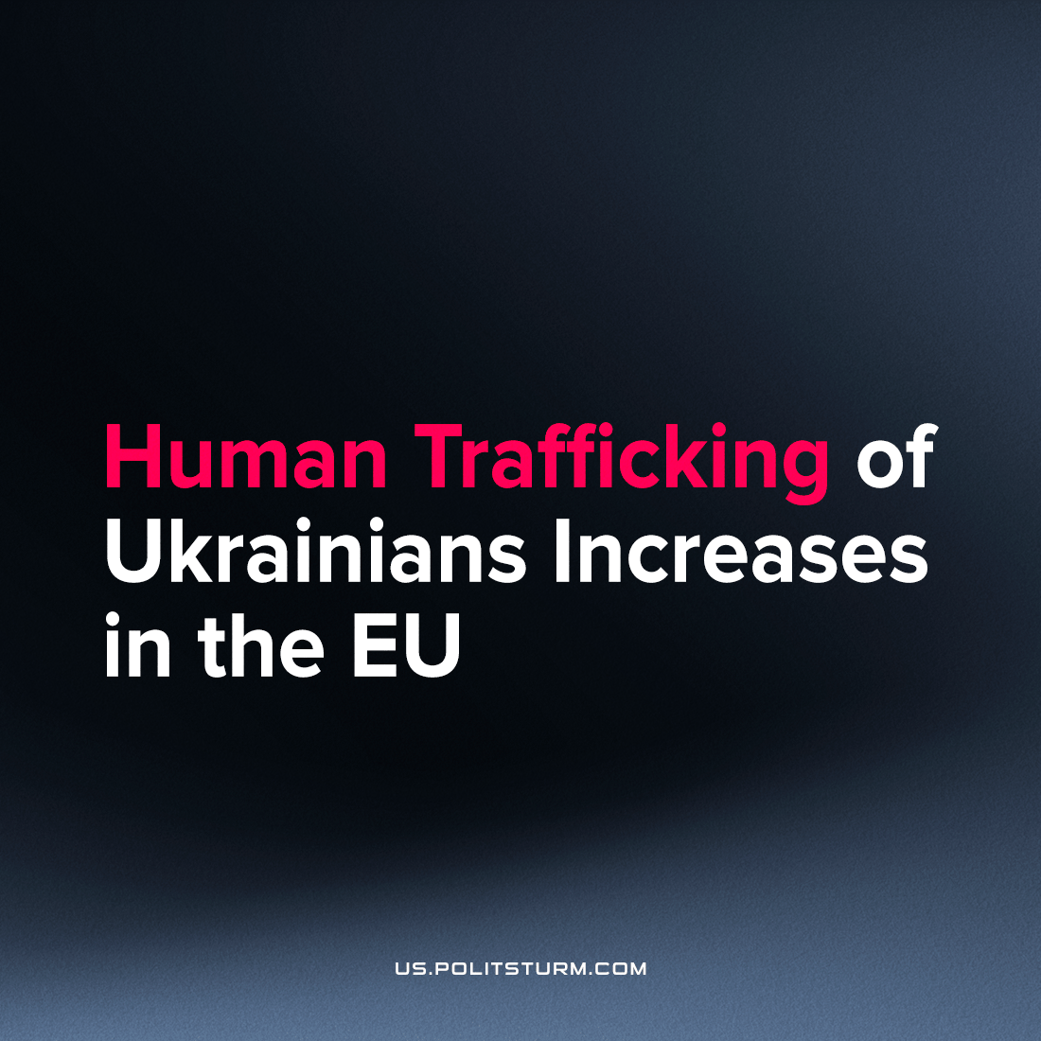

Original article
2022-12-08
2 min read

On November 29th, deputies and social organisation representatives at a meeting of the European Parliament alerted the assembly to the increasing case number of trafficked Ukrainian refugees. The chairman of the Commission on Women's Rights, MEP Robert Bidron, mentioned an increasing number of "suspicious" proposals on the Internet related to Ukrainian refugees.
The meeting stressed that women are particularly at risk of becoming victims of traffickers. UN Women Deputy Director Jo-Anne Bishop said that economic hardship and physical insecurity put Ukrainian women at high risk of ending up in prostitution or the porn industry.
Slave traders actively use social networks and other online platforms that simplify the search and recruitment of potential victims. Together with the imperfection of European laws, this complicates the work of the bodies responsible for combating human trafficking. OSCE Representative Valiant Ritchie says:
"There are many attempts to recruit women and girls on social media."
He added that the Digital Services Law regulating online platforms in the EU says nothing about human trafficking. Ritchie believes that despite the "strong response" of the European authorities to human trafficking, current legislation does not cover the ongoing situation.
In addition to sexual exploitation, social organisations drew the attention of the European Parliament to the problem of forced labour and overexploitation. Legally, Ukrainians have the right to work in the EU thanks to the Temporary Protection Directive, which was introduced at the beginning of the hostilities. But not everyone can find an "official" job. As reports Suzanne Hoff from the Platform for International Cooperation for Undocumented Migrants, "Some people end up in informal circles."
The financial difficulties, the language barrier and the uncertain social status of most Ukrainian refugees force them to accept undeclared and low-paid jobs. Such workers disappear from the field of view of European legislation and are deprived of even those rather limited means for protecting their rights that it provides.
The employer of undocumented workers may impose unreasonable "fines" on them, endanger them at work, withhold wages, or not pay them at all. And if workers decide to challenge these violations in court, they will need to prove that they really worked for this employer.
It is unlikely that Ukrainian refugees will be able to improve their situation by silently waiting for "decisive action" from European bureaucrats. Human trafficking is already well known not only in Europe. Criminal networks operate between Ukraine, the countries of Europe and Central Asia. Last March, the Commission reported that Ukrainians were among the most frequent victims of human trafficking within the EU even before the war.
Despite all the efforts of the European authorities since the beginning of the war, the scale of human trafficking has only increased. The difficult financial situation of Ukrainian refugees, the lack of permanent housing, the language barrier, and their inability to adapt to new conditions lead to a further expansion of the slave trade in the EU. However much the EU claims to oppose this turn of events, it is a factual matter that these people create value for European capitalists with cheap labor and the flourishing black market in human goods.
Sources: 1

Original article

