Ukrainian President Prepares to Sell Ukrainian Resources to U.S. Corporations
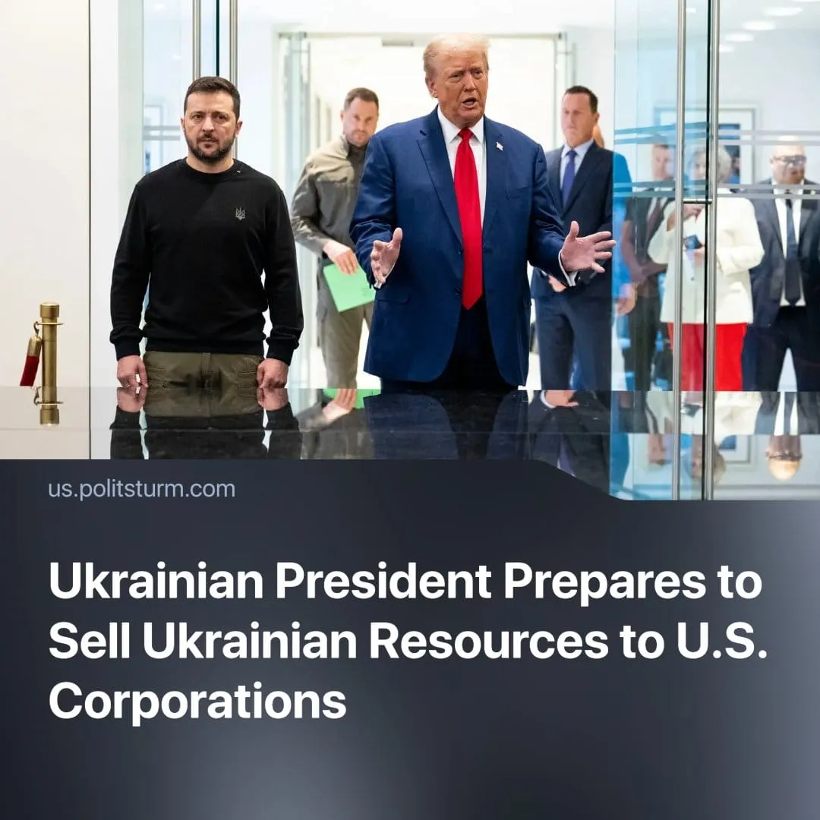

Original article
2025-02-17
2 min read

During negotiations with the new U.S. administration in early February 2025, Ukrainian President Volodymyr Zelenskyy proposed granting American companies access to Ukraine's abundant rare earth minerals in exchange for continued U.S. military assistance.
Details. On February 7, President Zelenskyy suggested a partnership where Ukraine's rare earth minerals would be exchanged for U.S. military aid.
► Four days later, U.S. President Donald Trump indicated that Ukraine had "essentially agreed" to allow the U.S. access to $500 billion worth of rare earth minerals. He proposed that these resources could serve as a form of "payback" for the nearly $300 billion in U.S. aid.
► On the same day, U.S. Treasury Secretary Scott Bessent announced a visit to Ukraine to discuss American access to these critical minerals and energy resources.
► Later President Zelenskyy refused to sign the agreement, though not because of the resources, but because there were no security guarantees, meaning that he was fine with it in principle. A similar agreement could be negotiated soon.
Context. Negotiations over granting U.S. corporations access to Ukraine’s rare earth minerals are taking place against the backdrop of an escalating trade war with China, the world’s largest supplier of rare minerals.
► Ukraine possesses vast reserves of various resources and a developed industrial base, making it a target for both Russian capital and Western "allies."
► After taking office, the new Trump administration reduced financial and military aid to Ukraine.
Important to Know. For years, Ukrainian authorities claimed that their struggle against Russia was about independence and freedom. However, now this "freedom" comes with a price tag — selling off the country’s natural wealth is becoming official policy. This follows the classic imperialist model: military support is never free but is instead ‘exchanged’ for markets and resources.
► The Ukrainian leadership attempts to disguise this reality with rhetoric about "equal opportunities for all partners" and appeals to Ukraine’s importance for Western capital. In reality, they only confirm that Ukraine’s role is determined by the strategic interests of Western powers.
► The U.S. leadership has long framed its aid to Ukraine as a fight for "democracy." In his last address, Joe Biden portrayed "Ukraine’s freedom" as his personal achievement.
► Now, with Donald Trump back in power, the U.S. position has become more explicit: aid must be "repaid," and Ukraine must grant access to its resources. The difference between Biden and Trump turns out to be minimal — both serve the interests of American corporations.
In Conclusion. Wars over resources and markets are an integral part of imperialism. Dependent countries become battlegrounds for competing capitalist powers. The solution to the problem is not to switch to the pro-Chinese camp, but to fight against all imperialist camps.

Original article

