UK Will Spend £115 Million on Mass-Surveillance
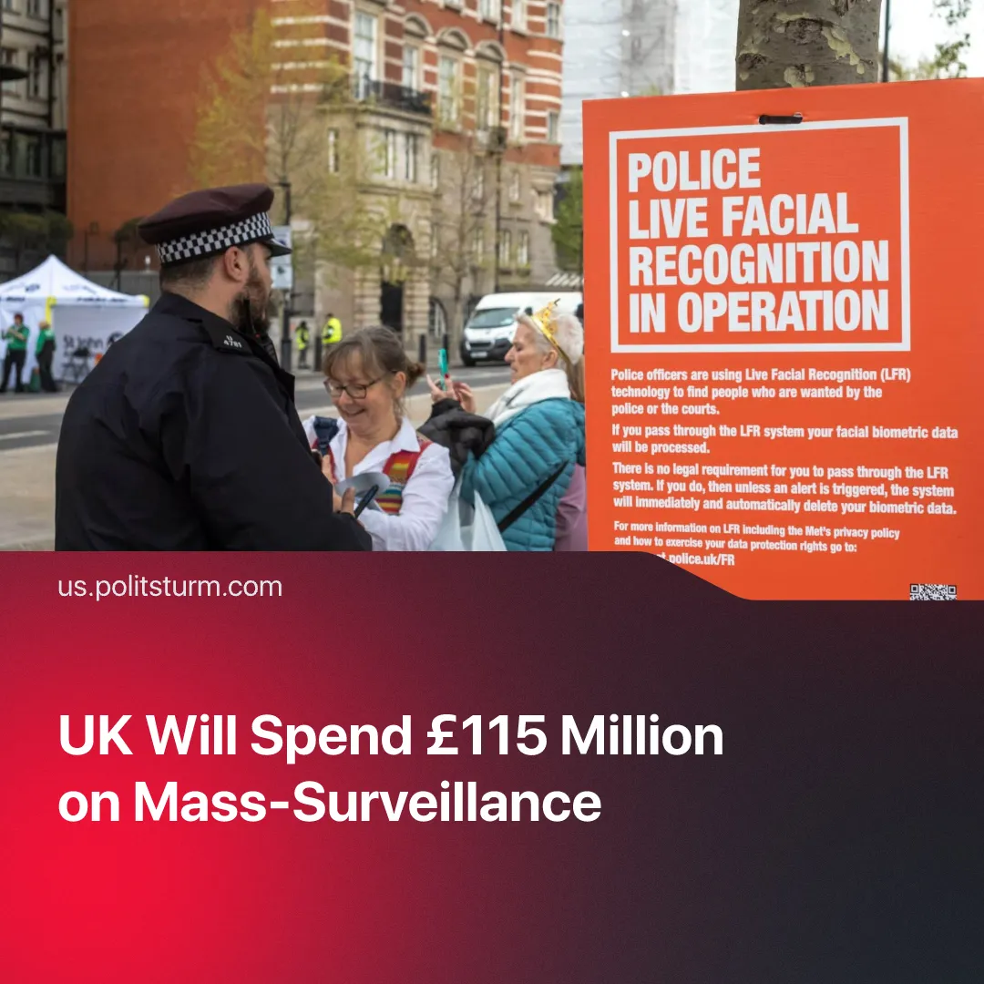

Original article
2026-02-05
2 min read

UK government plans a £115 million expansion in mass-surveillance and policing, preparing the grounds for the increased exploitation of labour.
Details. The UK Home Secretary announced that British police forces will massively expand the use of Live Facial Recognition (LFR), such as through the acquisition of 40 new LFR vans, bringing the total to 50.
► Alongside this, £115 million (US$157.3 million) will be invested over the next three years into a National Centre for AI in Policing, known as Police.AI. The Israeli-based Corsight AI – implicated for using AI for surveillance in Gaza and leading to the wrongful detention of hundreds of Palestinians – will be subcontracted to help provide this service.
► These are all part of the Home Secretary’s blueprint for a slew of new police reforms. Other developments include the creation of a new National Policing Service – dubbed “British FBI” – with the official intention of countering terrorism, criminal gangs, fraud and other cross-border crime, as well as the merger of Britain’s 43 separate police forces, likely into 12 "mega forces".
► In parallel, the House of Lords amended the Children’s Wellbeing and Schools Bill to ban VPN access for under-18s, mandating provider identity verification and further eroding online anonymity. A recent amendment to the UK’s 2025 Online Safety Act will require social media and dating apps to take “proactive steps” – including pre-scanning private messages – to curb unsolicited nude images and other harmful content.
Context. The Online Safety Act marked a major expansion of internet surveillance by requiring age verification on certain websites via selfies or government-issued ID, nominally to protect children from harmful content. VPNs remain one of the only practical ways to bypass this system.
► The UK has been using LFR at a limited scale since 2015, gradually expanding it over the years. Alongside this, this Labour government tried to roll out a digital ID, which will be on peoples’ phones, containing their name, date of birth, nationality or residency status, and a photo. The measure was rolled back after public backlash.
► As Britain ramps up militarisation ahead of wider imperialist confrontation, these measures function to police the social consequences – suppressing protest, tracking workers, undermining working-class organisation, and enforcing austerity as public funds are diverted from social spending into war and repression.

Original article

