The UK Will Lower Minimum Voting Age in Elections
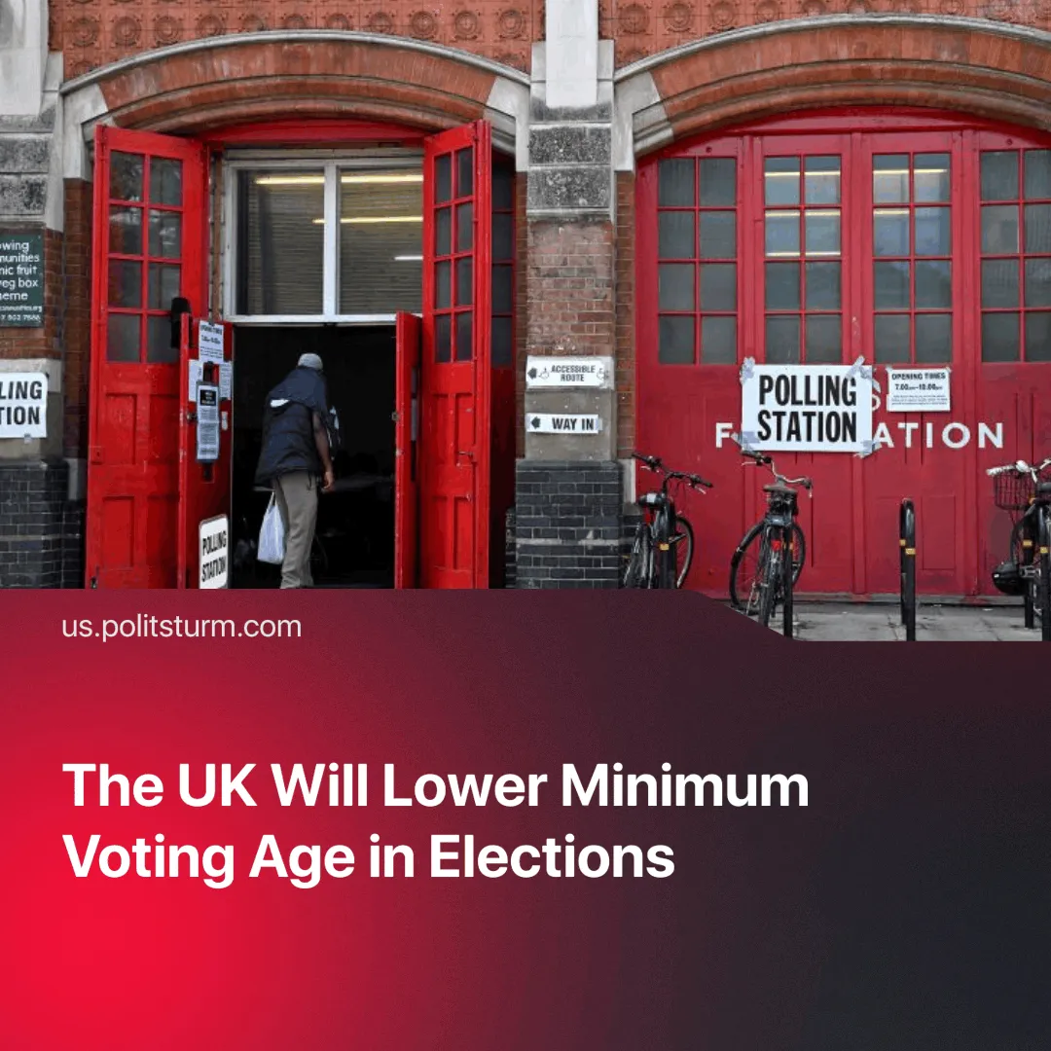

Original article
2025-07-24
1 min read

The UK aims to “restore trust in democracy” by lowering the voting age to 16, despite no significant popular demand.
Details. The new law, announced by the Labour government as a move to “modernise democracy” and “restore trust,” will allow 16- and 17-year-olds to vote in the next general election.
► Additional measures in the bill include extending voter ID to include UK bank cards, and including “tougher new rules” against disruption of the political process.
► Despite longstanding youth voting advocacy organisations, recent polling shows that only 32% of the UK public support lowering the voting age to 16, while 57% oppose it and only 18% of 16–17-year-olds say they will "definitely vote" in the upcoming election.
Context. In 1969, the UK became the first European country to lower the voting age to 18, following the lowest post-war turnout in 1966 and widespread public apathy.
► The change did not offset the 3.8% turnout decrease in the 1970 election, as the law provided nothing material to tackle general political apathy.
► Voter turnout in Britain’s 2024 election was 59.7%, which was the lowest since the 2001 election. Decline in turnout has become a general trend across Europe.
► Since winning the 2024 election, Labour’s approval rating has sunk to approximately 25% and one report states that “young people are the least positive about Britain’s fairness and its democratic systems”.

Original article

