UK and US Settle on Lacklustre Deal as Britain Looks Towards Europe
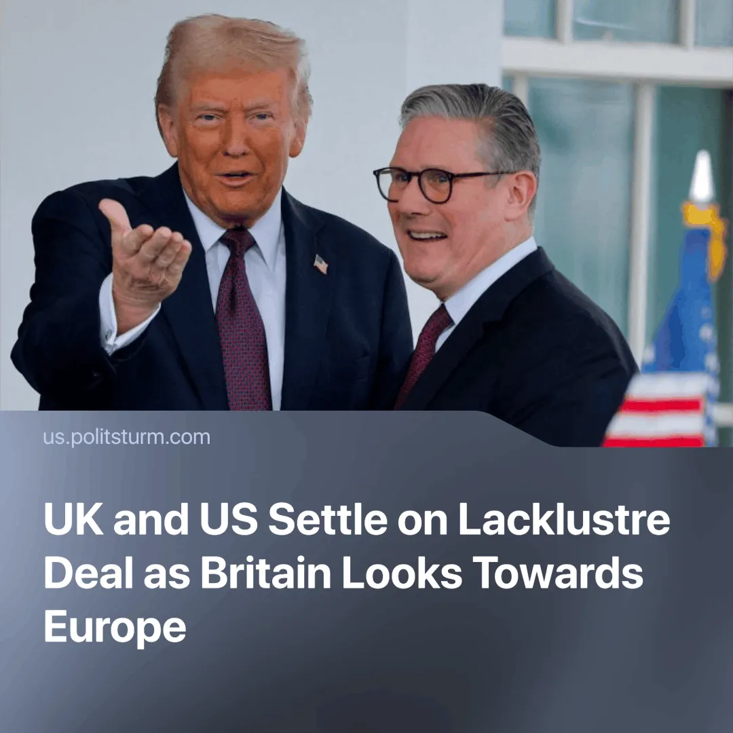

Original article
2025-05-15
3 min read

London and Washington have finally agreed on a deal, but behind the scenes, the deal may prove to be a disappointment. As some UK capitalists are already looking for a further trade deal with Europe, we see Britain's increasing dependence on other stronger economies.
Details. Keir Starmer promises that the deal will "save thousands of jobs in Britain", while Trump says that it is "a great deal for both countries". But many may see this deal as lacklustre, as it merely reverses some of the tariffs imposed on "Liberation Day" and opens the British economy even further to the US, with the White House saying that this deal "increases the competitiveness of US companies" in the UK.
►Tariffs on British cars (the UK's biggest export to the US, worth $11.9 billion last year) were agreed to be reduced to 10% for up to 100,000 cars—above this, exports face a 27.5% tariff. The 25% tariff on British steel and aluminium has been reduced to zero.
►No agreement has been reached on pharmaceuticals, but the UK has said that work will continue on this and on the remaining reciprocal tariffs, which have yet to be decided. Last year, the UK exported $8.76 billion worth of pharmaceuticals—the second largest UK export to the US—and the US exported $5.3 billion worth.
►Importantly, most UK products will continue to face a general tariff of 10%, keeping prices higher than before “Liberation Day.”
►The 2% digital services tax—that affects big tech companies, which the UK considered lifting to appease the US—will remain. The US has expressed disappointment with this decision.
►The UK has scrapped its import tax on US ethanol and both countries have agreed reciprocal access to beef, with UK farmers given a quota of 13,000 tonnes. The entrance of cheap US goods has raised concerns with British farmers.
Context. The United Kingdom has been desperately seeking a deal with Trump since his “Liberation Day”. The International Monetary Fund predicted that the UK economy would be one of the hardest hit in the current trade war.
►The UK's steel-making capacity was already in decline, and the tariffs have accelerated this trend, almost wiping out the country's vital ability to produce virgin steel.
► These tariffs also reflect US attempts to contain China’s influence and reassert global dominance—pressuring countries to accept unfavourable deals in exchange for reduced tariffs, as seen with Mexico and Canada and force others into a semi-dependent state.
► The EU accounts for 41% of the UK’s exports. Whilst currently maintaining a trade deficit, as UK companies struggle to compete with their American counterparts, British capitalists might now see a pivot towards Europe as more profitable.
Important to Know. This deal is not a full trade agreement like the one with India, because that'd have to go through the US Congress. It simply partially reverses “Liberation Day” tariffs. Noticeably, Chancellor Rachel Reeves had already said that trade with the EU was arguably more important. Now, the Bank of England wants to push for an EU trade deal.
►The British economy—one of the birthplaces of capitalism—is now severely weakened by capitalist competition and uneven economic development. Without the strength to stand on its own, the British capitalists will seek to ally themselves with various stronger powers, especially as tensions between them increase.
►But America's difficult stance is leading many British capitalists to see the EU as the potentially more profitable option, and although Starmer is seeking to negotiate with all parties, the redivision and polarisation of the world is likely to force the country to choose between one or the other. If a deal with the EU proves more profitable, it is possible that the UK will instead move closer to its European partners.
►Critically, a move towards the EU won't undo the UK's dependency; it will just change its master, and the working class will continue to pay the heavy price for the capitalists' profits.

Original article

