U.K. Teachers to Strike Against Poor Conditions
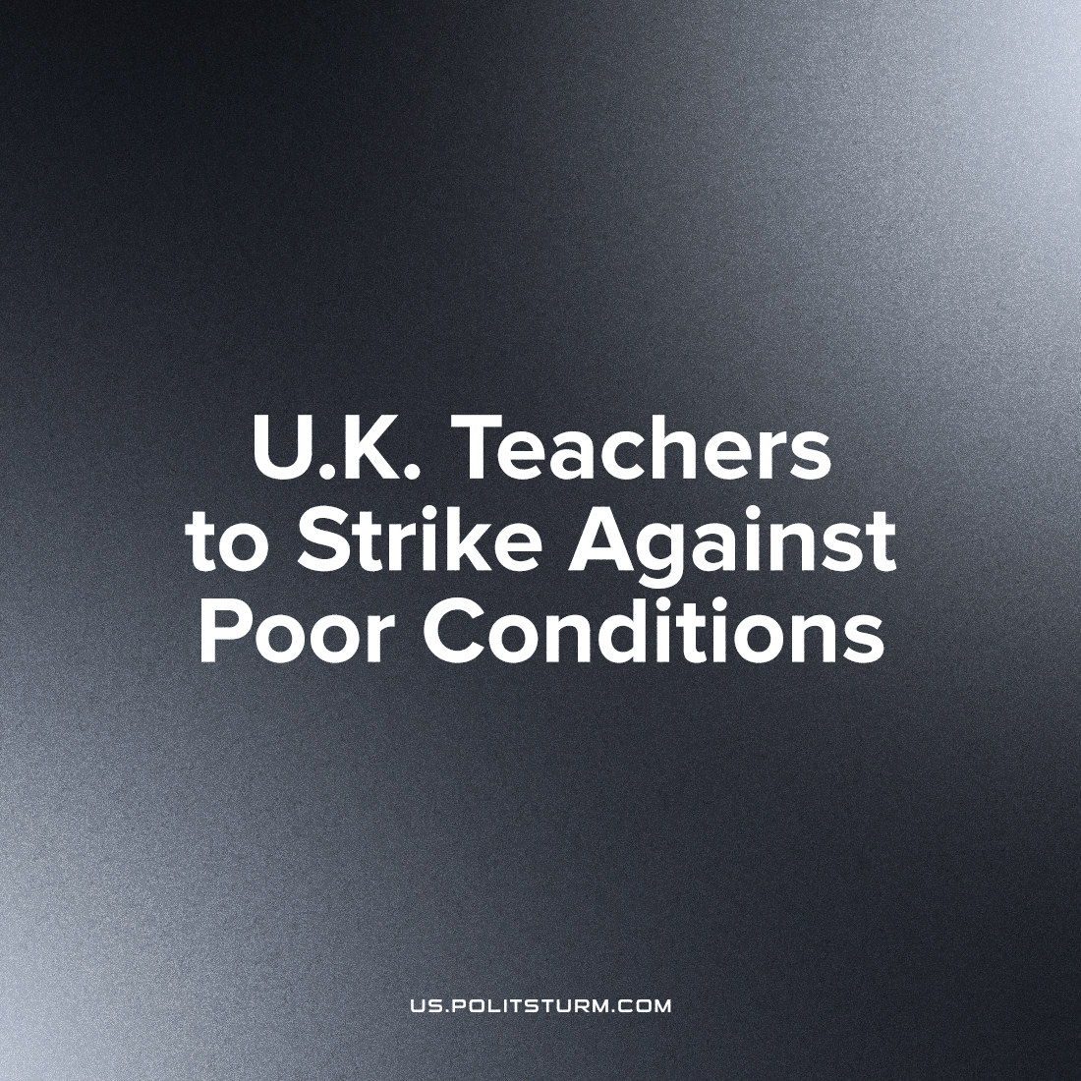

Original article
2023-04-21
5 min read

Teachers in England and Northern Ireland have chosen to join their fellow workers in strike actions which have rocked the U.K. for months. Like most of the country's professions, teachers across Britain and Northern Ireland have seen a dramatic drop in their wages, standards of living and working conditions. These pernicious effects are imposed on the children whose education is reducing in quality, driving forward the destruction of living standards in the United Kingdom.
The wave of strikes among English educators manifested in March with 200,000 members of National Education Union (NEU) members walking out in protest over their worsening pay and conditions. On Wednesday next week, at least five teachers' unions representing tens of thousands in Northern Ireland will stop work for the whole day, responding to parallel developments in Stormont and the failure of negotiation after their half-day strike in February, while the English teachers will strike the following day.
The situation for those that educate the nation’s youth is dire with the Institute for Fiscal Studies revealing that teachers’ salaries had fallen ‘by an average of 11% between 2010 and 2022’ after taking inflation to account; most state school teachers in England have had a mere ‘5% rise in 2022.’ In addition to the pay cuts that teachers have had to face, work conditions are dire for educators with a recently-leaked government report stating that some ‘22% of teachers work more than 60 hours a week or more.’ The report was commissioned by the Department for Education and the research was carried out in Spring of 2022 but has not yet been published. The leaked document - marked confidential and titled Working Lives of Teachers and Leaders - was produced for the DfE in order to ascertain the situation regarding teacher supply, recruitment and retention: all of which are a critical problem within the education sector of Britain. More than 11,000 teachers and leaders across primary and secondary schools were questioned. ‘The report found:
- one in four were considering leaving the state sector in the next year, with most of this group citing high workload as a key factor behind their decision;
- three-quarters of teachers said they spent too much time on paperwork, while two-thirds of senior leaders felt they were spending too much time responding to government policy changes;
- one in five teachers surveyed reported that satisfaction with their working life was "low";
- nearly half of those responding said they would rate their anxiety levels as "high";
- almost three-quarters of teachers said their workload was "unacceptable".’
The timing of the leak is significant; the damning evidence of the report were revealed at a time when the strikes were on hold as the NEU debated on the government’s pay deal which was announced as ‘the final offer.’
But this was not the only factor in the decision for teachers’ unions to vote for industrial action.
In January 2023, Ruth Perry, Headmistress of Caversham primary school in Reading, committed suicide after her school was downgraded from ‘Outstanding’ to ‘Inadequate.’ In the aftermath of this tragic event it quickly became clear as to the reason why such a horrifying occurrence took place: The Office for Standards in Education, Children's Services and Skills (commonly known as Ofsted), a non-ministerial department of the government that reports to Parliament responsible for assessing the standard of education across the country, had been incredibly draconian in its assessment of Ruth Perry and Caversham school.
The school, as a matter of fact, was deemed to be an exceptionally good one by the inspectors (who have the absurdly conceited title of ‘His Majesty’s Inspectors’) with the quality of teaching, the attitude of the teachers and the enthusiasm of the pupils being lauded in the report. However, the inspectors had deemed Ruth Perry’s leadership as “inadequate” and as such all the praise that the inspectors had could somehow be ignored for the overall grading; the school subsequently went from the top to the very bottom of the scale that rates schools. The reasoning as to why is morbidly comical: the inspectors had seen a child “flossing,” a dance that is popular among children due to viral videos and the children’s videogame Fortnite, was ‘evidence of the sexualisation of children at the school.’ In addition, one of the inspectors had told a teacher that they had ‘seen child-on-child abuse which turned out to be a playground fight.’ Considering that these incredibly banal observations of normal juvenile behaviour were deemed so disturbing by the inspectors that it warranted the school being downgraded to the worst possible grade (ignoring the actual quality of education) it can be safely assumed that these inspectors never actually had childhoods themselves and sprung forth fully formed like Athena.
The case has since led to a seismic debate as to the efficacy and justice of Ofsted inspections. Teachers up and down the country are publicly revealing the toll that inspections take on the mental health of educators especially in light of dysfunctional Ofsted actually is. In spite of how seriously they take themselves, Ofsted is not incredibly rigorous: ‘Schools that were rated good or outstanding used to be assessed every four years, but routine inspections for outstanding schools stopped in 2011 so resources could be focussed on the worst-performing institutions.’ Ruth Perry had never been inspected by Ofsted despite having been a headteacher at the primary school for 13 years. It was only recently, after fears that education standards would slip due to the pandemic lockdowns did Ofsted start evaluating outstanding schools once more. This reveals the immense pressure that educators are under, their reputations are ruined no matter how hard they work and devote their lives to educating the next generations by an organisation that can pass summary judgement based on one criterion; this places undue emphasis on the staff for their perceived faults despite the fact that schools lacked any oversight for up to ten years.
In spite of all their talk of improving education and that no child will get left behind, the bourgeoisie desires this state of affairs for which they are responsible: by cutting back standards and funding prospective educators are driven away from taking up what used to be a lauded profession, the state can subsequently further privatise schooling (something that has begun with “sponsored academies”) which excludes the vast majority of the populace from accessing the means to better their conditions; subsequently, good education becomes a monopolised prerogative of the bourgeoisie’s children, leaving the masses of young proletarians lacking the mental tools to understand their condition. Using Ofsted as a weapon against teachers and state-funded schooling has backfired: the death of Ruth Perry combined with the industrial action of educators has shone a light on the ruined state of schools in Britain.
On the 4th of April 2023, it was announced that the NEU’s delegates at their annual conference had voted to continue industrial action of pay and funding following the Easter holiday. This means that should the government continue to refuse to negotiate with strikers that schools could face periodic shutdowns until the start of the summer holidays. This reveals the real nature of the capitalists: they would rather children miss vital days at school than give teachers a well-deserved pay rise and schools the funding and support that they desperately need.
It would be a mistake, however, for Communists to simply agitate for Department of Education funding; the working-class remains under the teaching of their bourgeois exploiters no matter how well-funded the education sector is. Only a workers' state can address the vast discrepancies in quality and access to education that the children of the U.K. face. The results speak for themselves: the U.S.S.R. inherited a poor, rural and technologically-stunted society from the robber Tsarist regime and within 50 years of comprehensive mass education became the first state to send the children of ordinary workers and farmers into space; eliminated illiteracy and electrified their nations to bring technological and cultural development to the every corner of their country. The equal to which is hardly found in the most developed capitalist economies today. These human victories are impossible in an exploiter's imperialist society; only the leadership of the proletariat can bring about the full potential of mankind.
Sources: 1

Original article

