The British Parliament Admits Sanctions Against Russia Are Not Working as Planned
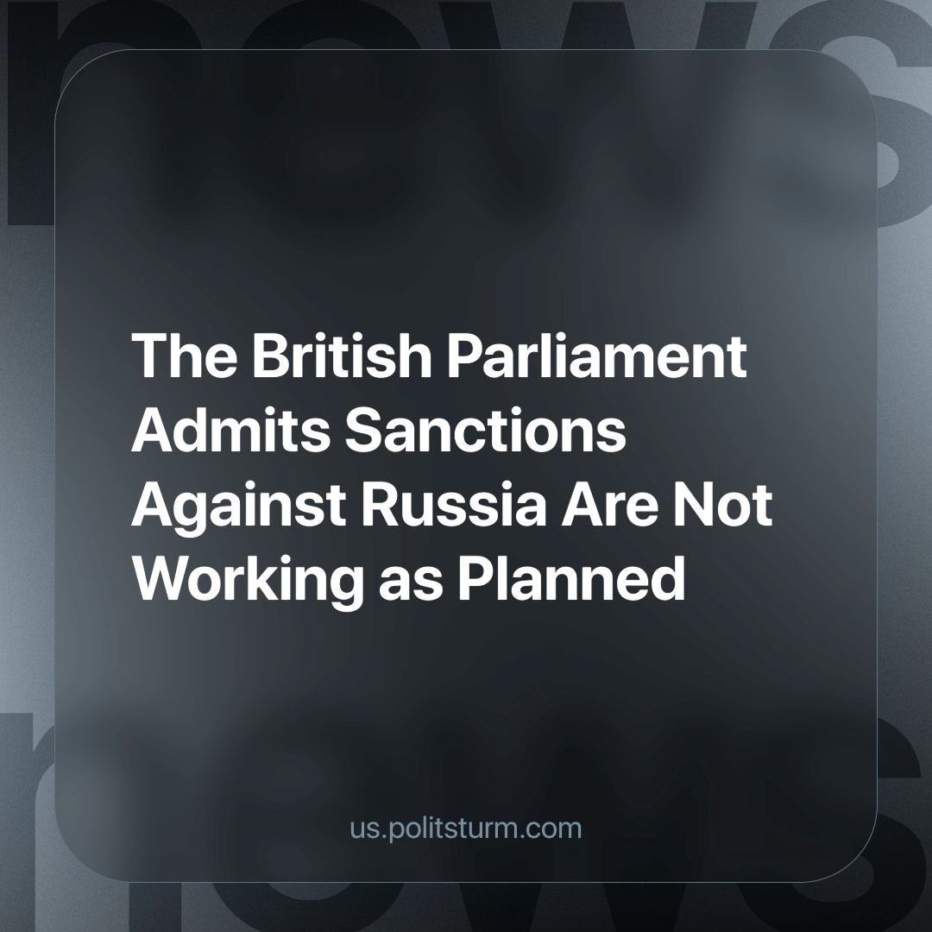

Original article
2024-05-27
2 min read

In March 2022, the Treasury Committee of the House of Commons opened an inquiry into the effectiveness of sanctions on Russia. The inquiry, closing submissions this March, is now reviewing the evidence received from interested parties, including many financial associations. The main problem, according to the committee chairman, is that Russia's economy continues to grow.
The UK manufacturing sector continues to cooperate with the Eurasian Union and does not want to break this connection, so British companies that have stopped direct trade with Russia continue to increase supplies to Armenia and Kazakhstan. One expert suggested paying attention to the increasing volume of sales to these countries because, through them, everything necessary can get to Russia.
A British law firm that has previously defended Russian clients believes that the sanctions list also needs to be revised because it contains many people who are not directly connected with either Russian politics or the military.
Frozen Russian assets are a stumbling block for the British: they can be confiscated, which would be justified from a legal perspective. However, experts caution those who want to seize assets, as Russia may respond by confiscating British assets. Moreover, this may negatively affect the outflow of capital, as it would make British capital less credible to other nations due to involvement in a political conflict.
Western countries claim that they are fighting Russian aggression; in reality, they are engaged in an economic war to protect their own oligarchs' interests. This is perfectly displayed when the same Western countries show complicity and inaction regarding Israeli war crimes. The war against Russia, however, is not as effective as they would like. This is due to the contradiction between the immediate desire and need for profits of individual capitalists who trade with Russia and the potential benefits of displacing Russian capital.
British politicians are currently negotiating and bargaining, calculating how it will be more profitable for them to change the sanctions to continue trade, to hit Russia's economy, to cream off its assets, and not to lose their own. If this requires removing Russian oligarchs from the sanctions list, they will do it. No care is given to the harm that sanctions cause to ordinary citizens in both the UK and Russia.
Any state in a market economy makes decisions in the interests of its own large businesses and is indifferent to ideas about good and evil or the well-being of ordinary citizens. Only a socialist state represents the interests of workers, who have no private property to divide violently among themselves, making it able to follow a genuinely peacekeeping policy aimed at economic and social development for the good of all workers globally.
Source: RBC - “The British Parliament called for a review of the sanctions list of Russians” dated May 2, 2024.

Original article

