UK Recorded Highest Number of Modern Slaves
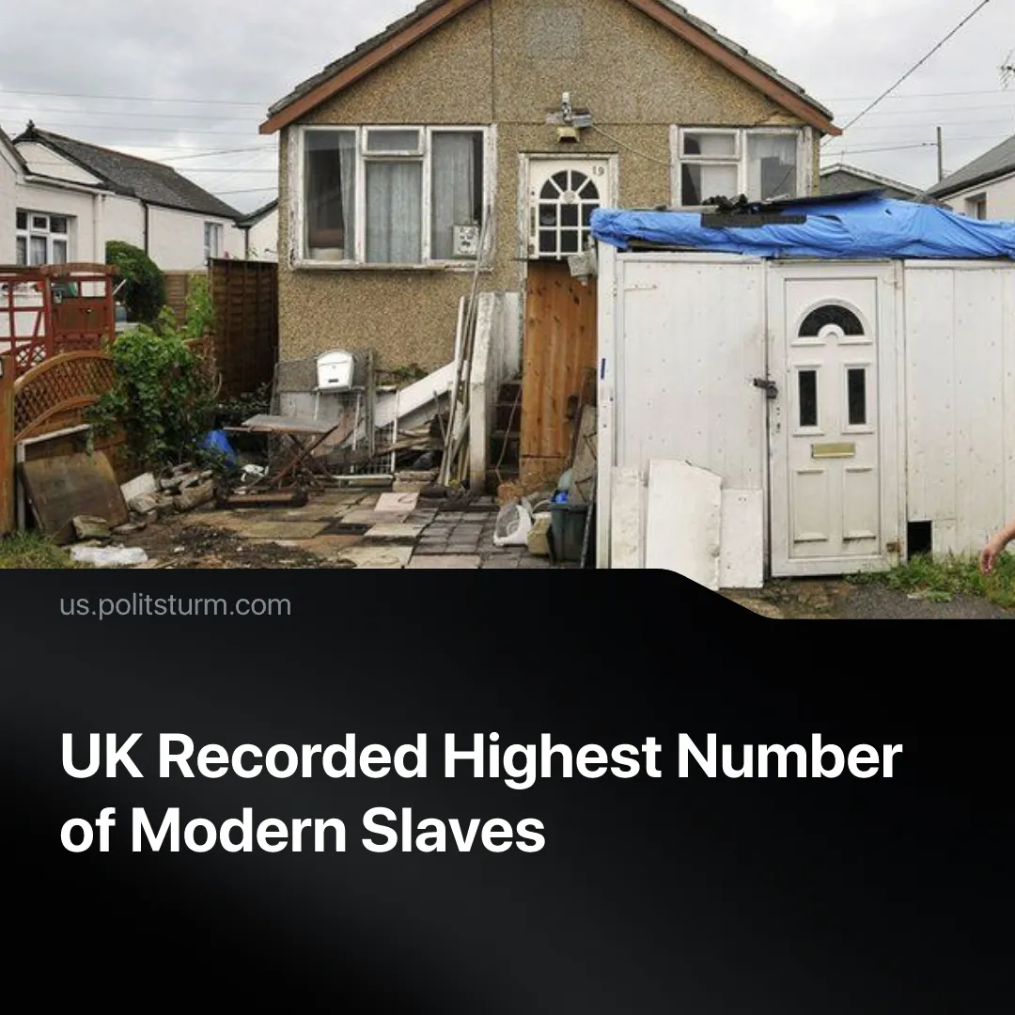

Original article
2026-05-16
2 min read

The UK has recorded its highest ever number of modern slavery due to increasing work insecurity, poverty and displacement.
Details. The UK’s independent anti-slavery commissioner (IASC) has identified 23,411 potential victims of modern slavery in 2025, up 22% from the previous year. The report notes that trafficking, forced labour and sexual exploitation are becoming harder to detect as criminal networks use advanced technology to expand and intensify operations.
► Over a fifth of potential victims are UK nationals, the largest group, followed by Eritreans (13%) and Vietnamese (9%). The report also highlights the predominance of child victims, with the number safeguarded rising by around 50% over the last five years – due to both improved identification and increased harm.
► It’s explained that the main causes for this are rising living costs, debt and insecure work domestically, as well as global issues such as increased conflict, migration pressures and climate change, all of which make people more vulnerable to increased exploitation in search of employment and income.
Context. The UN defines modern slave labour as work “exacted from any person under the menace of any penalty and for which the said person has not offered himself voluntarily.” But all wage labour is performed under the threat of starvation, making modern slave labour an intensified form of this relation, distinct from chattel slavery where people themselves were property.
► As UK economic growth “flatlines”, living conditions for workers continue to deteriorate. Child homelessness has reached a record high of over 176,000, food prices are set to rise by 50% due to the energy crisis caused by the Iran war, while unemployment has climbed to its highest rate in nearly five years. Meanwhile, 7.1 million households struggle to afford essentials.
► Internationally, the number of global armed conflicts reached its highest levels since World War II in 2024, with multiple countries aiming to increase remilitarisation to Cold War levels, at the expense of workers. Meanwhile, the UN continues to warn of a worsening climate crisis, pointing out that the past 11 years have been the warmest on record.
► The far-right Reform UK has made major gains in recent council elections. The party promises to repeal the current administration’s limited concessions to workers – such as worker and renter protections and the Equality Act – while increasing deportations and building migrant detention centres, meaning vulnerable immigrants may accept even worse working conditions to avoid deportation.

Original article

