United Kingdom’s Prime Minister Promises to Accept Responsibility if Inflation isn’t Halved
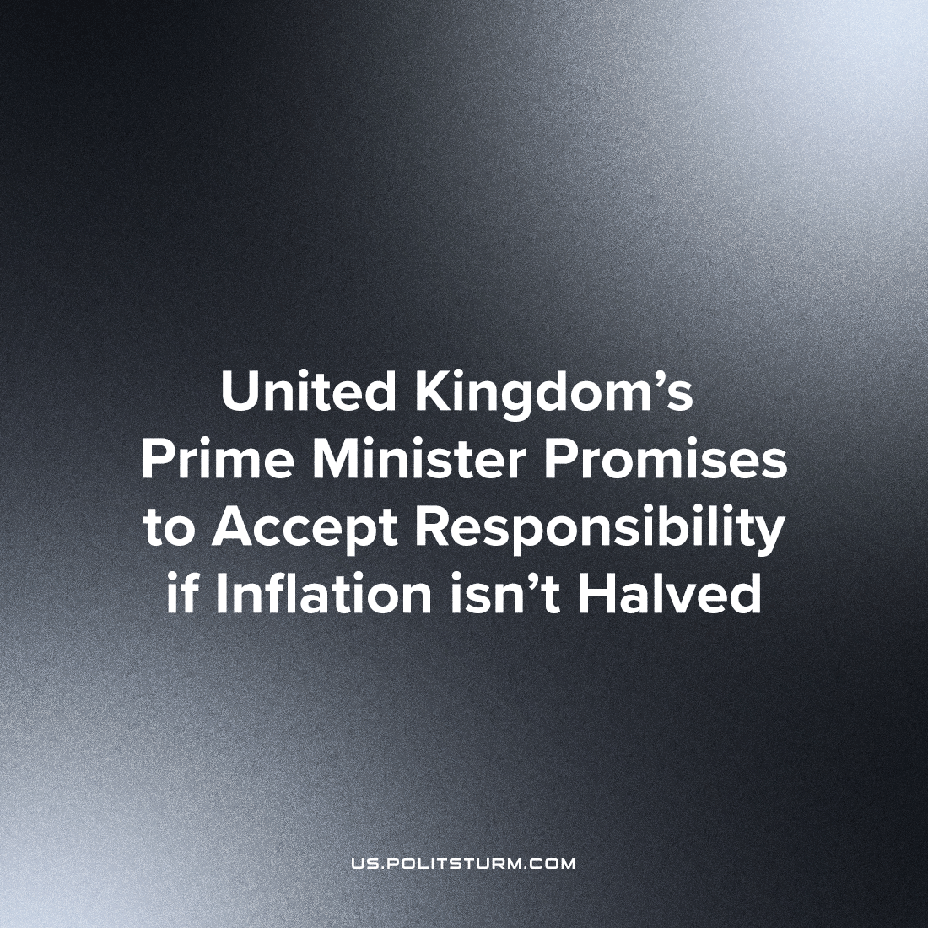

Original article
2023-06-11
2 min read

During his visit to the U.S., Prime Minister Rishi Sunak promises to accept personal responsibility if inflation isn't halved by the end of the year. This announcement follows high ongoing inflation in the U.K. since 2022, spurning an enduring cost of living crisis. Sunak seeks to reassure the British working class that the assault on their rights and livelihoods is merely temporary.
His declaration is most likely one of the many empty promises that are all too common with capitalist politicians. However, even if he does accept personal responsibility (which at most will mean a comfortable resignation) this will be a meaningless gesture and spectacle. Inflation is caused by the capitalists collectively raising the prices of goods and the “necessity” of this is demonstrated by their obscene profit (while normal people have to live with under austerity), especially the record profits of the oil and energy companies – sectors where inflation “coincidentally” is the highest. As such, it is not Sunak’s fault for inflation as an individual, it is the fault of the capitalists as a class, and he is responsible to the extent that he serves as their representative to govern the country. By declaring inflation to be “on him” individually, he is seeking to misguide working people into believing systemic problems are the fault of individuals and therefore can be solved within the existing system. This ideology and its influence – liberalism – is a cancer in the working class movement that must be excised wherever it is found.
In addition, he is also responsible as the representative of the British capitalists as a class for the crimes of deprivation, starvation, armed conflict, and homelessness that he inflicts on his compatriots as well as ordinary working people around the word in dependant countries. Crimes that he and others like him will never be prosecuted for under the existing state of things, as capitalists don’t care about the plight of working people and (in line with liberal ideology) regard poverty as the fault of the poor.
The workers don’t need capitalists, or their ideology, or their politicians, or their lies and instead should seek to consolidate power in their collective hands as a class in order to oppose the capitalists and eventually build a new socialist order bereft of inflation and deprivation.
Source: 1

Original article

