UK Labour Party Announces New Budget
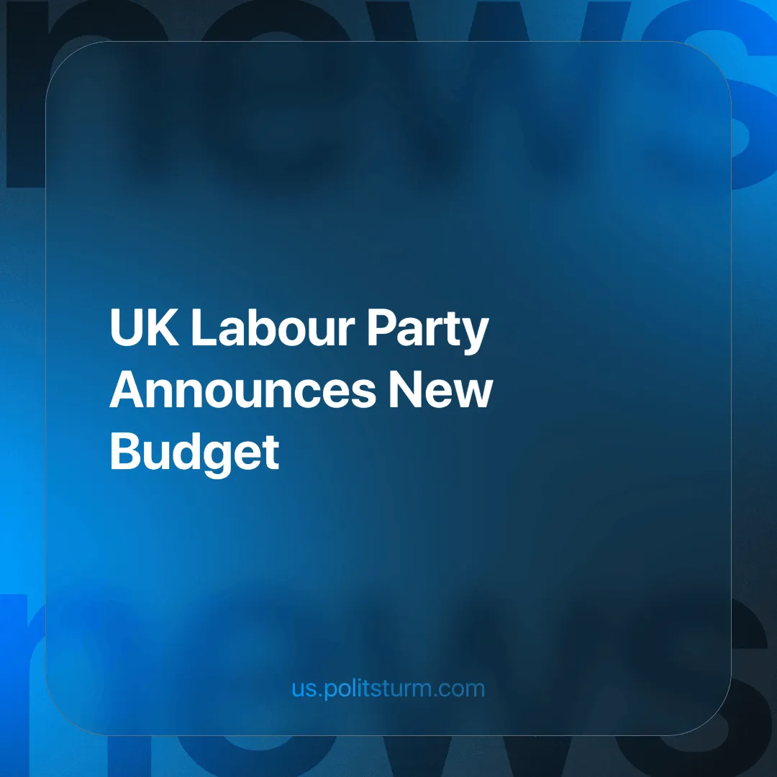

Original article
2024-11-08
3 min read

On Wednesday 30th October 2024, Chancellor Rachel Reeves presented the new Autumn Budget to Parliament. It has been described as a long-term plan for Britain, focused on helping the country grow and recover from the 14 years of Conservative rule.
Conservative rule was marked by a struggling National Health Service (NHS), which has a waiting list of 7.5 million people in England, and now 4.3 million children living in relative poverty, to name but a few of its traits [1].
Labour won the election earlier this year with an extremely low turnout (52% of British adults [2]) and a campaign that promised to undo all the misery caused by the Tories during their many years in office. We wrote about the falling turnout in an earlier article.
The Autumn Budget gives us a glimpse of how Labour intends to run its government. The mainstream media is portraying this budget as one of "mammoth change" [3], with an emphasis on more investment and higher taxes on business to fund this investment.
Firstly, it's important to analyse how some of these changes are not as titanic as some make them out to be. For example, the new £22.6 billion extra promised for the NHS is an increase of 3.4% between this year and next.
Though this is above what was on offer in the years before the pandemic, overall it is in line with the average historical investment the NHS has received. Since 1955, funding for the NHS has increased by an average of 3.6% a year in real terms, rising to 5.5% under New Labour and 2.8% under the last two Conservative governments [4].
Secondly, the budget is extremely lacklustre in other areas. For example, the minimum wage will rise from £11.44 to £12.21 an hour. This falls short of the £15 minimum wage that the Trade Union Congress (TUC) previously said was needed [5]. Ironically, the TUC now says that Reeves has 'acted decisively to deliver an economy that works for working people' [6].
Thirdly, Labour has promised not to increase National Insurance for the average worker. To pay for this new investment, National Insurance has been increased for private companies. This higher tax unfortunately will likely lead to stagnant wages, higher prices and redundancies as companies will seek to offload these increased costs to keep profits high, since the economy remains in private hands and corporations can and will shift the burden onto workers.
The £2 bus fare cap has been changed to a £3 cap. As many workers barely make it by with the cost of living crisis, a small increase like this on a cost for an essential service that many rely on daily will have devastating effects on those that are currently struggling to survive. Taxes may not rise directly for the worker, but they will still feel a further squeeze on their purchasing power.
It is also important to note that a further £2.26 billion in military aid will be sent to fan the flames of conflict in Ukraine, furthering Western imperialist interests by weakening their competitor, Russia, and continuing to tie Ukraine into debt bondage.
When we analyse the content of the budget and peel back the pro-worker rhetoric, we see that it doesn't really improve workers' living conditions, despite Labour's promises.
This is because of the way the system is set up, specifically liberal democracy. Current democracy is neither "pure" nor "above class", it belongs to the capitalist class. Politicians are bought and sold by the capitalists through lobbies, sponsors and, in many cases, are themselves part of the capitalist class. Because of this, politicians represent bourgeois interests. In an earlier article we showed how Labour is prepared to sell out the British working class to a congress of billionaires for the sake of attracting private investment.
Even if a reformist party has the best of intentions, the possibilities for real change remain limited because the economy remains largely in private hands, whose interests are opposed to those of the workers. For this reason, parties acting within the framework of liberal democracy and through parliament can only attempt to influence the economy indirectly.
The economy is subject to the laws of the market, which contains inherent contradictions between labour and capital. Regulation, subsidies and taxes, therefore, can only do so much and can never resolve the fundamental contradiction. The solution therefore is workers' democracy and social ownership of the economy.
To achieve socialism there must be a communist party that guides the working class in a long-term struggle against capitalism, earning the trust of the workers by helping them in their struggle for short-term gains.
At present there are no communist parties capable of doing this. If you want to help Politsturm in the task of building such parties, join our organisation.
Sources:
[1] The Guardian — Tories’ 14 years in power will be remembered for Brexit, cuts and chaos — 23/05/2024
[2] The Guardian — Lowest turnout in UK general election since universal suffrage, report shows — 12/07/2024
[3] BBC — Rachel Reeves doesn’t mind if you don't like her Budget — 31/10/2024
[4] The Economist — Britain’s budget is heavy on spending but light on reform — 30/10/2024
[5] TUC — We need a £15 minimum wage. This is how to get there — 23/08/2022
[6] TUC — Autumn Budget: a plan to start rebuilding Britain — 31/10/2024
[7] Gov.uk — UK strengthens national security and bolsters Ukraine’s war chest with £2.26 billion military loan — 22/10/2024

Original article

