UK Government Announces Minimum Service Levels for Striking Teachers
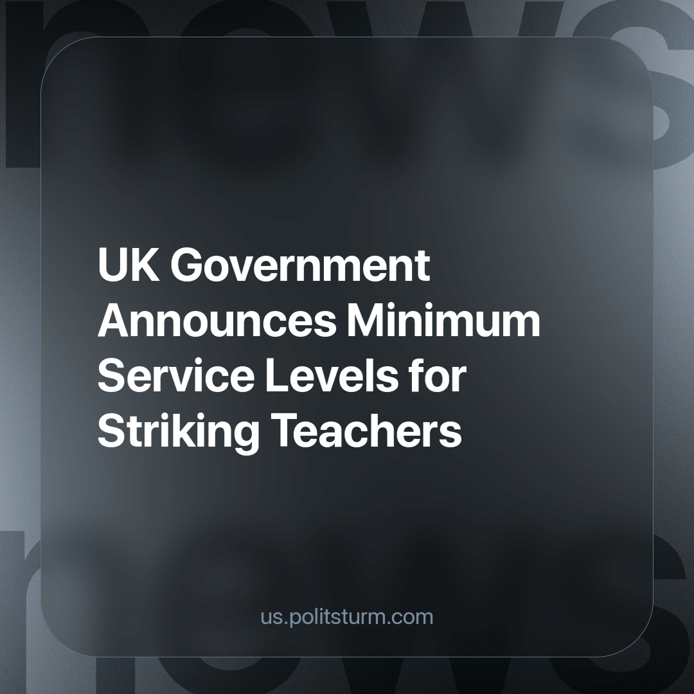

Original article
2023-10-26
2 min read

The UK government has revealed its intention to enforce minimum service levels for teachers on strike. This decision has been announced as a response to the recent strikes by teachers, who successfully won a 6.5% pay rise, which we have written about previously. Under this new directive, schools must maintain a minimum number of teaching staff on strike days, further limiting the rights of teachers to fight for their rights, livelihoods and working conditions through collective bargaining. The state’s approach demonstrates its commitment in attempting to curb the power of organised labour and stifle workers' attempts to address their grievances, revealing its essence as merely a tool for administering the rule of the capitalists.
This announcement, while seemingly focused on ensuring that students are not adversely affected during strikes, is, in fact, an attempt to suppress the legitimate struggles of the working class. It reveals the government's blatant disregard for the issues plaguing the education system, such as chronic underfunding. The lack of proper funding, as we had written about before, is pushing nearly 90% of English schools to the brink of bankruptcy.
While working-class parents are struggling to afford basic necessities for their children under the still ongoing cost of living crisis, the government's response is to limit teachers' right to strike and fight for their interests, as well as the interests of the education sector as a whole, rather than addressing the root causes of these crises. It is the worker, not the capitalist (or capitalist state) that cares about the profession that they do every day, and it is the capitalist (or capitalist state) that is solely concerned with money and profitability.
Furthermore, the ongoing crisis schools collapsing due to the use of Reinforced Autoclaved Aerated Concrete (RAAC) in construction that has yet to be addressed, shows the sheer extent of the government's neglect for the education system. It's evident that the ruling class prioritises profits over the well-being of the next generation, as a substantial investment without is needed to address the risks posed by RAAC in school infrastructure. We have covered this crisis in detail earlier. This underfunding highlights the government's willingness to sacrifice public spending on school renovations to fund private initiatives that have proven inadequate. As illiteracy, children going to school hungry, and teachers suffering from in work poverty are all on the rise, the divide between private interests and public welfare has never been clearer.
This state manoeuvre to regulate minimum service levels for striking teachers aims to undermine the unity and power of the workers' movement. The government's timing, coming after the recent strike wave and pay rise for teachers, seeks to divide the labour movement by isolating them and defeating them separately.
As the RAAC crisis underscores the deteriorating state of public education, workers must recognize the need to unite in order to sustain their struggle. Isolated and spontaneous actions make it easier for the ruling class to suppress the working class's demands. The path to securing the rights of teachers and improving the education system in particular, and securing a different type of society where the interests of workers is enshrined in law in general, lies in strong and united labour movement under the leadership of a communist party that stands for the genuine objective interests of the working class.
Source:
https://www.bbc.co.uk/news/education-67168084

Original article

