UK to Increase Annual Military Spending by £13.4bn
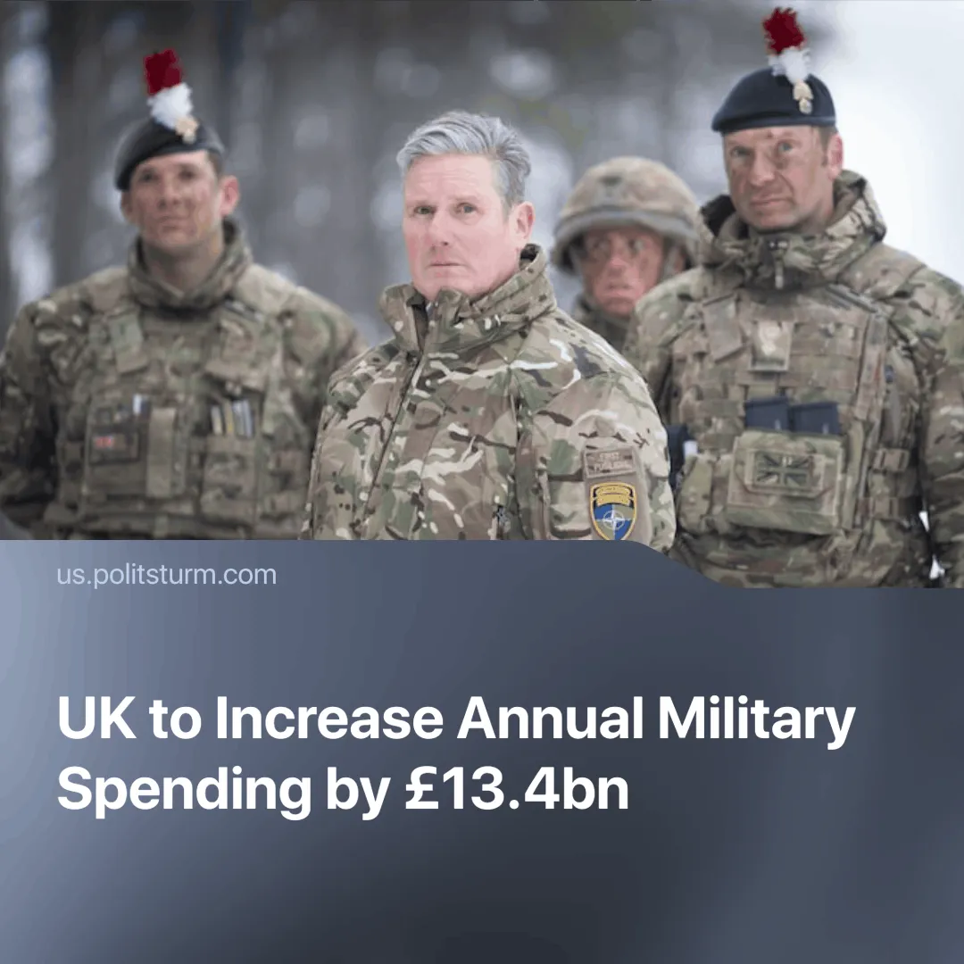

Original article
2025-02-28
2 min read

Following the recent US-Russia peace talks over Ukraine, British Prime Minister Kier Starmer announced plans to increase military spending by cutting foreign aid, arguing that we are entering a "dangerous new era."
Details. On the 25th of February, The UK Prime Minister announced a plan to increase annual military spending from 2.3% to 2.5% of national income from 2027.
► He explained in the House of Commons that this change would require an additional £13.4bn in annual spending.
► To finance this, the UK will cut its aid budget from 0.5% of gross national income to 0.3% by 2027, ensuring full funding for its military investment.
► US Defence Secretary Pete Hegseth praised the plan, describing it as a “strong step from an enduring partner.”
Context. Diverging interests between the US and the EU have begun to reveal themselves as Trump takes a more hawkish approach towards his supposed “allies”.
► The US and EU trade is mutually dependent. While the US is the EU's top export partner (accounting for 19.7% of exports outside the bloc in 2023), the EU also supplies the US with 32 critical products, predominantly pharmaceutical and chemical commodities.
► During his previous term—and reiterated in his current presidency—Trump urged NATO members to boost military spending to 5% of GDP.
► The US, as the dominant supplier of military equipment to the EU (55% of imports), uses tariffs and divisive rhetoric (including claims that the EU was “formed to screw the United States”) to assert the “America First” agenda of the new government.
Important to know. The UK relies heavily on trade with both the US and the EU. While trade with the EU is four times greater than with the US, the US remains the single largest trading partner of the UK.
► The UK capitalist class, forced by its dependencies, is attempting to assert itself as a middleman between competing capitalist blocs, exploiting these tensions to bypass trade restrictions and reinforce its economic standing.
► The Labour government's decision to shift funding from the soft power of foreign aid to military spending mirrors recent moves by the Trump administration, which cut USAID funding. Trump has since praised the decision. Foreign aid is typically used by imperialist powers to reinforce control over dependent nations, the shift to military funding shows that imperialists are preparing for direct conflict with other imperialists.
Conclusion. The UK’s shift to bolster military spending at the expense of foreign aid reflects the capitalist state's imperialist ambitions. By aligning itself with the US-led push for militarisation and positioning as a middleman between competing capitalist blocs, the Labour government sees this as an opportunity for growth whilst remaining dependent on the US.

Original article

