UK-Germany Pact Shows the Fragility of NATO Article 5
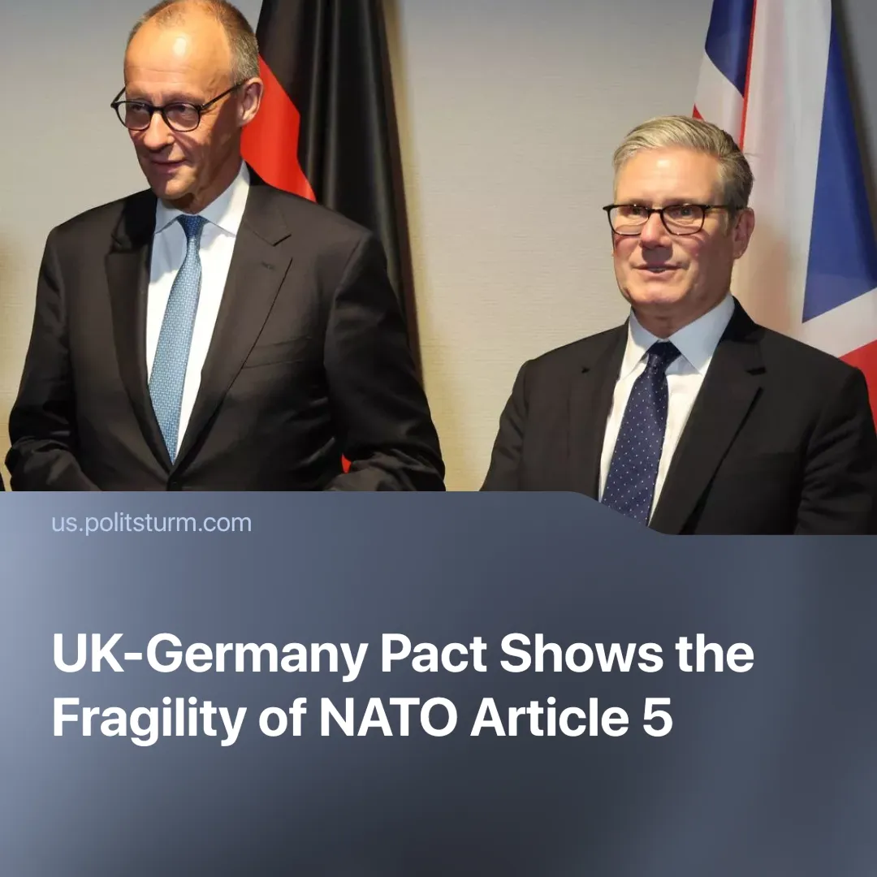

Original article
2025-07-14
1 min read

The UK and Germany will sign a deal which includes a mutual defence pact, effectively duplicating existing NATO commitments.
Details. The United Kingdom and Germany are in the “final stages” of preparing a wide-ranging defence treaty, expected to be signed on 17 July.
► The treaty is said to include a mutual defence clause, which will require both countries to provide direct military support if either one is attacked. This clause is redundant with NATO’s Article 5 defense guarantee, which already holds for all member states, including the US, UK and Germany.
► The deal includes agreements ranging from joint arms purchases, shared military technology, and cooperation to specific sectors like transportation and fishing rights.
► The US is the biggest member in NATO, but is notably absent from this deal between the UK and Germany. The EU is primarily represented by its most dominant economy, Germany.
Context. Trump’s “America First” agenda has pushed European countries to pursue closer economic partnerships and work toward consolidating themselves as an independent imperialist bloc. This treaty reflects a similar trend of military integration within Europe.
► In 2019, France, the EU’s second most dominant economy, signed a similar mutual defence treaty with Germany.
► We previously covered how NATO member states recently agreed to massively increase military spending. This strengthened both the U.S. arms industry and the EU’s growing defence sector.
► The UK continues to balance its ties with both the EU and the US, but has shown increasing alignment with the EU, as seen in this treaty and the recent EU–UK trade deal.

Original article

