British Construction Workers Four Times Likelier Than Average to Commit Suicide
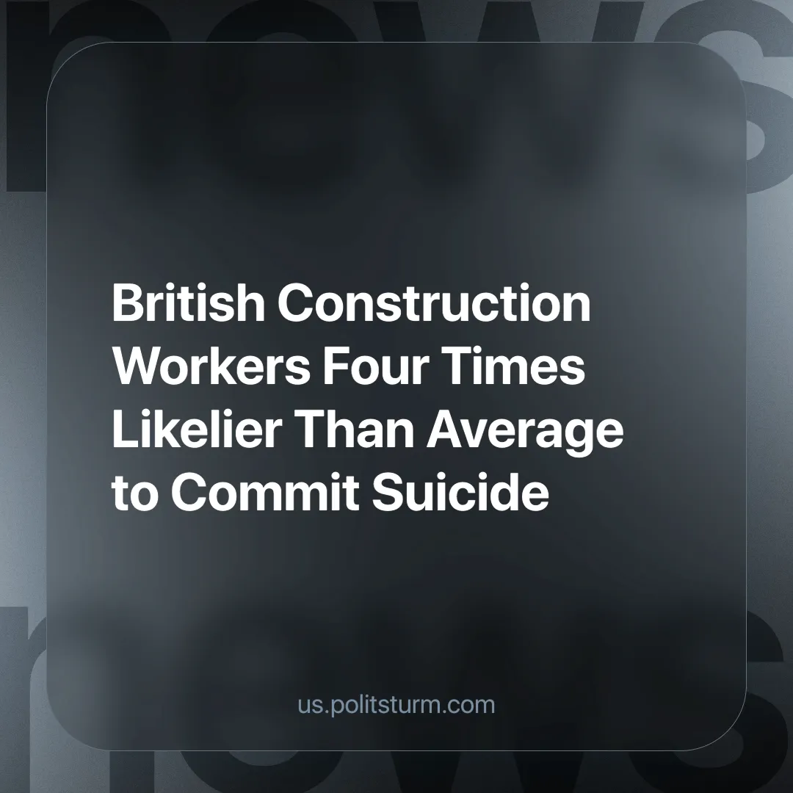

Original article
2024-12-30
3 min read

In the last decade, 7,000 construction workers have taken their own lives, this is four times the national average. Out of the 2.1 million construction workers in the country, 73% were affected by mental illness. [1]
The research was carried out by On The Tools, the UK's largest online social media community of tradespeople, which is now trying to raise £2.5 million to fund counselling for workers in the industry.
Alice Brooks, the company's brand manager, commented: "Because it's construction, I think people don't necessarily have the best perception of tradespeople, it's ignored."
“When you start factoring in isolation” she continues, “a lot of workers in this industry lone work or are self-employed and there is that feeling of isolation and loneliness."
"Then you add financial pressures, then industry pressures such as tool theft - we found 68% of tradespeople worry daily about tool theft which shows those wider pressures are affecting those in the trade."
The suicide rate in the UK in 2023 was the highest since 1999 [2]. Under the capitalist mode of production, workers are left to fend for themselves (this is exacerbated by the individualism of capitalism) and are vulnerable to financial difficulties. The sale of one's own labour is how most people afford the basic necessities for living.
Under capitalism, where employment is not guaranteed, workers experience enormous psychological stress as they try to keep their jobs, as the risk of homelessness, poverty and hunger are very real even in “developed” countries. They will in many cases accept poor working conditions, long hours and work when they ideally shouldn't, such as when they are ill or injured.
Unemployment and the desperation for work, serve as a threat to the employed workers, reminding them that they can be replaced by those even more desperate if they do not accept the most brutal exploitation by the capitalists. This ultimately turns worker against worker.
The On The Tools initiative can, at best, only slightly alleviate some of the symptoms of this problem, but it does not address the cause. Under capitalism, where the primary objective is to maximise profit, workers (or their labouring power, to be specific) are treated like any other commodity and can be replaced if they no longer make a profit for the capitalists.
Only socialism can tackle the root cause of this epidemic. Under socialism, the means of production are owned by the working class as a whole, and removing individual appropriation would serve the interests of society as a whole.
It is in the interests of society that everyone is employed, so job insecurity and the fear of losing one's livelihood would end. Healthcare would also be produced for use and not exchange, meaning that those suffering from mental illness would be able to get the treatment they need regardless of the profitability of it.
The way in which this new social system would be organised, alongside other state incentives, would lead to more cooperation between workers, through trade unions, mutual aid networks and collective ownership, so that workers would feel less isolated.
The mental health crisis among construction workers is not an isolated phenomenon but a more intense expression of the issues of labour under capitalism. The atomisation of the worker leaves them acutely vulnerable to injury, illness or any other problem that might affect their ability to work; this is something that exists to a greater or lesser extent in all occupations but is acutely felt in the construction industry. This vulnerability makes the industry particularly prone to mental health crises.
Efforts to provide some extra funding for counselling for workers cannot save the working class. The solution can only come from the workers themselves, the most advanced of whom should be organised in a vanguard party. Capitalism must be replaced with socialism.
Politsturm is currently working towards creating these vanguard parties which can lead the workers in their struggle. If you want to contribute to this effort, consider joining.
Sources:
[1] Sky News — Construction workers four times more likely to die by suicide as 7,000 lives lost, report says — 14/12/2024
[2] Office for National Statistics — Suicides in England and Wales: 2023 registrations — 29/08/2024

Original article

