UK Arms Saudi Arabia Under “Defence” Guise
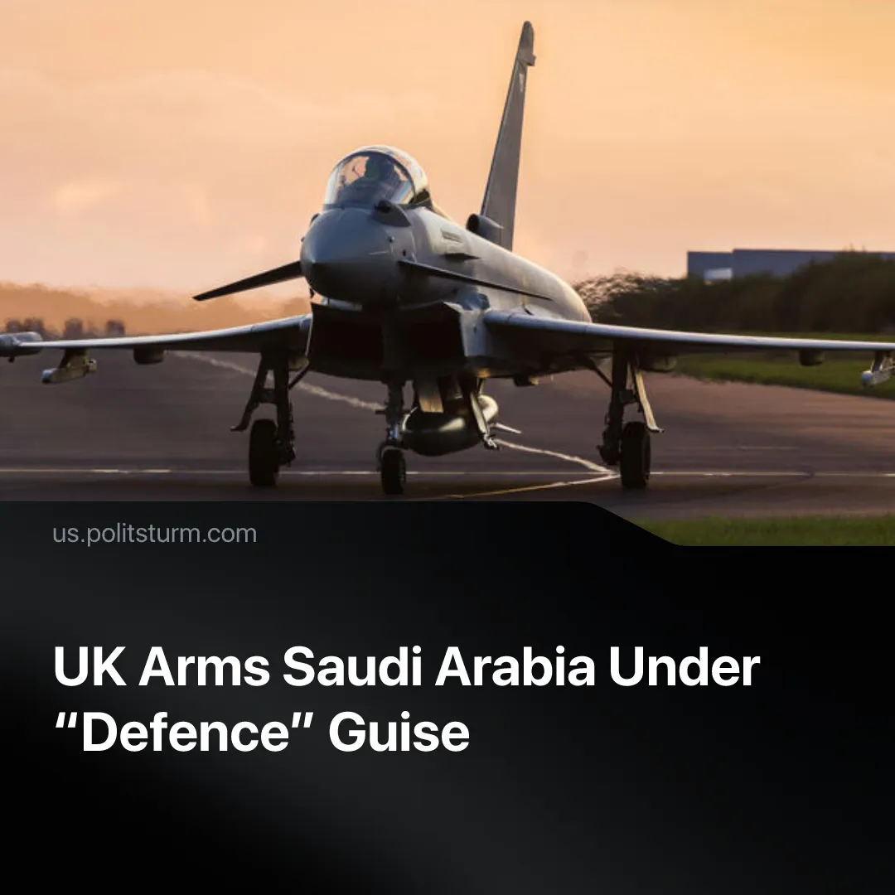

Original article
2026-10-28
2 min read

While Britain insists its escalating military budget is strictly for domestic defence, the government has agreed to send military jets to assist Saudi operations.
Details. On October 20, the UK government formally announced it is sending RAF Typhoon fighter jets and an RAF Voyager refuelling aircraft overseas to Saudi Arabia. This move further escalates a military buildup that Britain was already conducting. In recent months, London deployed a Sky Sabre air defence system, an RAF Voyager aircraft and military personnel to Saudi Arabia.
► As their name suggests, the Ministry of Defence insists the military, its budget and all operations are strictly for "defensive" purposes, including this deployment – the aircraft being there solely to protect Saudi airspace and infrastructure from Houthi drone and missile attacks rather than to conduct offensive strikes.
► The material catalyst for this “defence” is the securing Saudi oil infrastructure and Red Sea trade routes, which is done alongside other European and regional powers. France recently deployed troops, radars, and air defence systems to guard the major oil terminal at Yanbu. Britain now accelerates this effort alongside Pakistan, which has already sent 8,000 troops, as well as Egypt and Turkey.
► Rather than homeland defence, a massive chunk – about a third during the 2024/25 financial year – of Britain’s military budget funds global force projection. The military maintains 145 base sites across 42 countries, routinely deploying these assets for foreign interventions, including logistical support to Israel and assisting US operations against Iran.
Context. Britain is currently pushing a massive expansion of its military budget under the guise of national security. To secure public compliance for this buildup, the government and media justify the spending increases as a necessary measure to defend the homeland and prepare for “Russian aggression”.
► London's commitment to continually increase its military budget to meet NATO targets is not a rationally thought-out plan for domestic defense. Washington demands a minimum spending from member states in order to assist it with its own force projection. However, even with these major budget hikes and direct military assistance in the Middle East, Trump still openly condemns the UK's efforts as insufficient.
► This expanding military budget is paid for directly by the working class through the sacrifice of basic public services. As the state guts these vital resources, working-class health is deteriorating rapidly, with healthy life expectancy now dropping below the legal retirement age in 90% of the country. The Treasury has explicitly admitted to raiding civilian infrastructure to fund the military, formally announcing plans in Parliament to slash capital budgets across civilian departments to bankroll the Ministry of Defence.

Original article

