UAE Leaves OPEC as Hormuz Disruption Hits Rivals
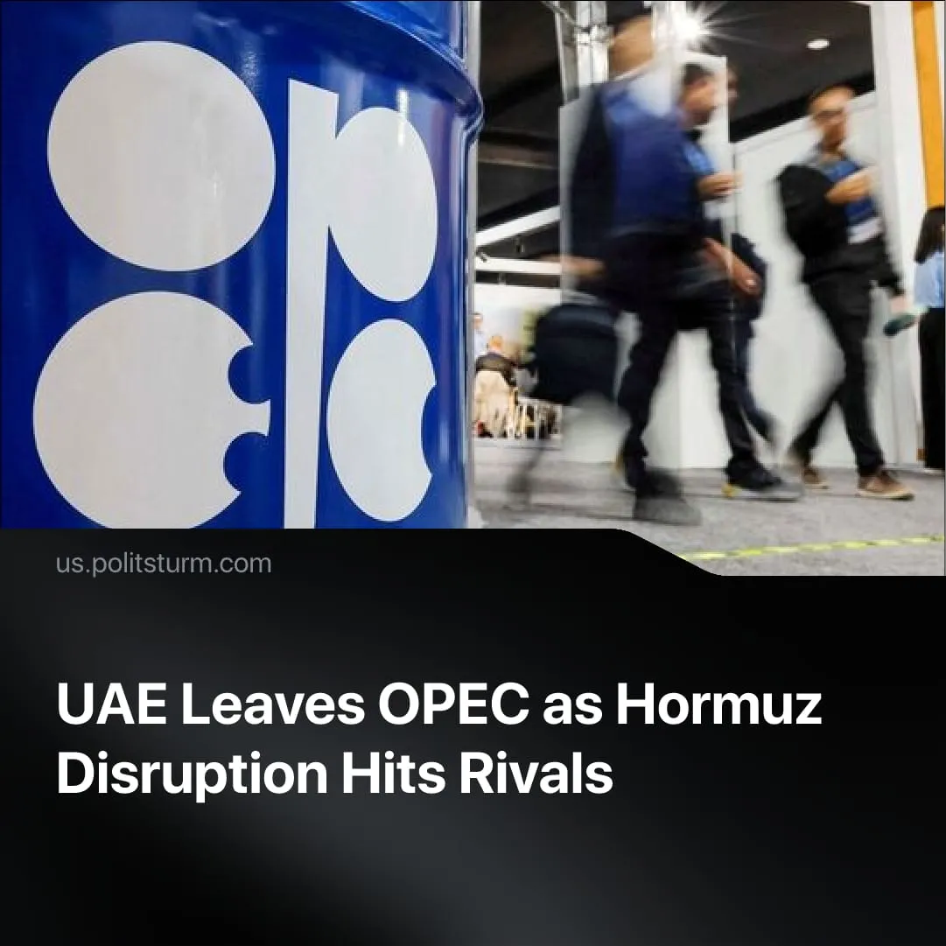

Original article
2026-05-02
2 min read

UAE leaves the OPEC cartel, freeing itself from production quotas, whilst the Hormuz blockades seize other members' export capacity.
Details. After 60 years of membership, the United Arab Emirates has left the Organisation of Oil Exporting Countries (OPEC) and OPEC+, capitalist oil cartel organisations that coordinate global supply and prices. The exit frees the UAE from quotas that capped output at 3.2–3.4 million barrels per day, despite capacity near 5 million – an extra 1.5–1.8 million barrels, equal to roughly 1–2% of global oil demand.
► The UAE framed the exit as a purely economic “policy” decision, with the Energy Minister saying it has “no political connotations” and is intended to ensure readiness for the future. He added that the timing would have “minimal” impact on prices and producers, while noting the world “needs more energy.”
Context. Tensions within OPEC reflect a longstanding contradiction between Saudi Arabia, the cartel’s dominant producer, enforcing output limits to manage prices, and smaller members seeking to expand production. The UAE has repeatedly pushed to raise its baseline to reflect increased capacity.
► During the US–Iran conflict, Donald Trump linked US military protection of Gulf states to oil prices, saying the US “defend[s] many of these nations for nothing” while they “take advantage of us by giving us high oil prices.” Simultaneously, the UAE and the US discussed a potential currency swap to support the UAE economy amid the conflict-related disruption. Trump has also stated that their leaving OPEC is “great.”
► OPEC’s share of global oil output has fallen from over 50% to around 30% as rival production expanded, with the United States now accounting for about 20%. The formation of the expanded OPEC+ in 2016 temporarily restored influence to around 50% of supply, but this is set to fall to roughly 45% following the UAE’s exit.
Important to Know. Under monopoly capitalism, cartels emerge to regulate competition between large capitals and gain monopoly profits, but this cooperation is temporary and unstable, breaking down as each seeks to expand its own share of the market.
► The UAE’s exit demonstrates this. The Strait of Hormuz disruption has constrained export capacity for most Gulf OPEC producers. Now is the perfect time for the UAE to gain an advantage by expanding output, bypassing the chokepoint via the Port of Fujairah, Khor Fakkan Port, and the Habshan–Fujairah pipeline.
► This is bound to sharpen inter-imperialist rivalry within the Gulf, where economic competition is already expressed militarily, such as in Yemen, where the UAE and Saudi Arabia have supported opposing forces.

Original article

