U.S. Workers Have Lost $1.3 Trillion During Pandemic
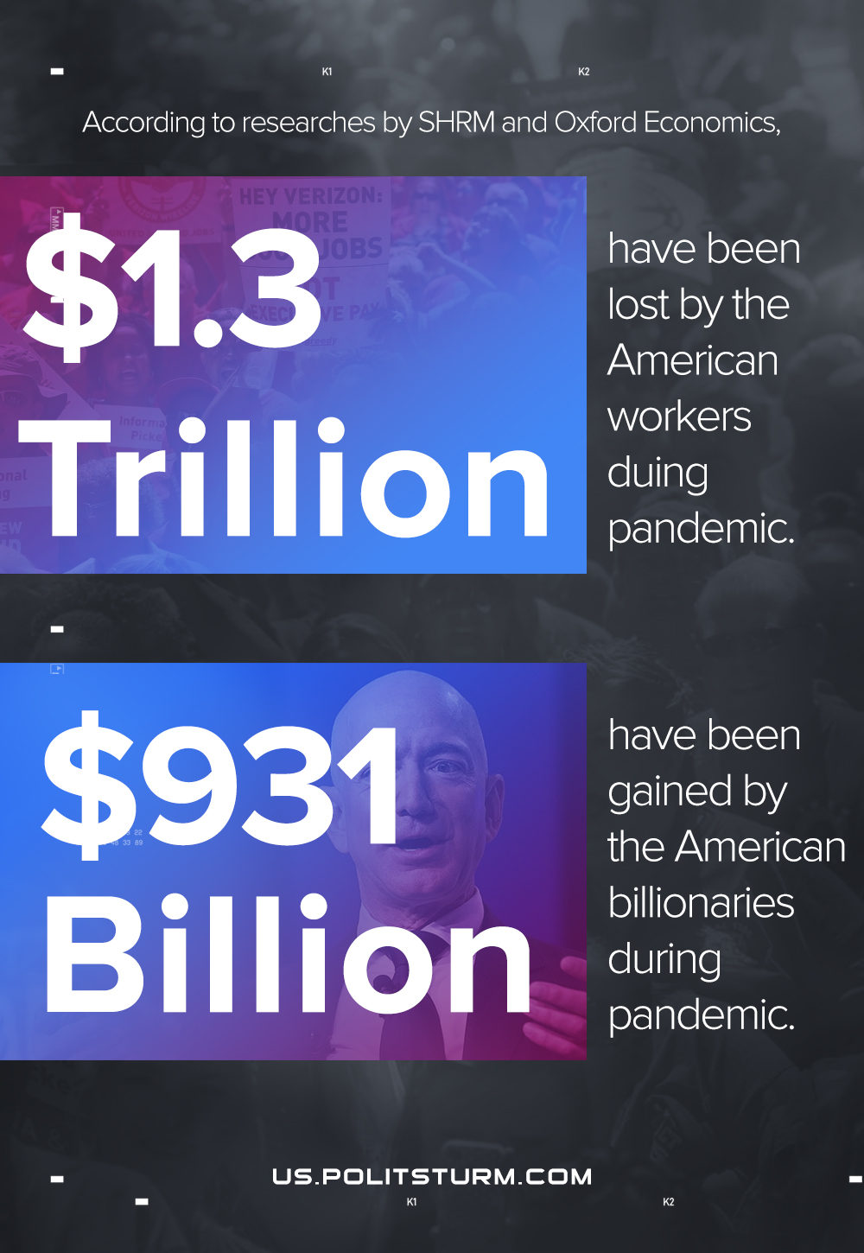

Original article
2021-02-18

Sources in description.

American Billionaires That Got Richer During COVID

Unsupported element: IFRAME
https://www.shrm.org/about-shrm/press-room/press-releases/pages/survey-us-workers-have-lost-13-trillion-in-income-during-pandemic.aspx

Original article

