U.S Workers Depression Rates Increase Drastically
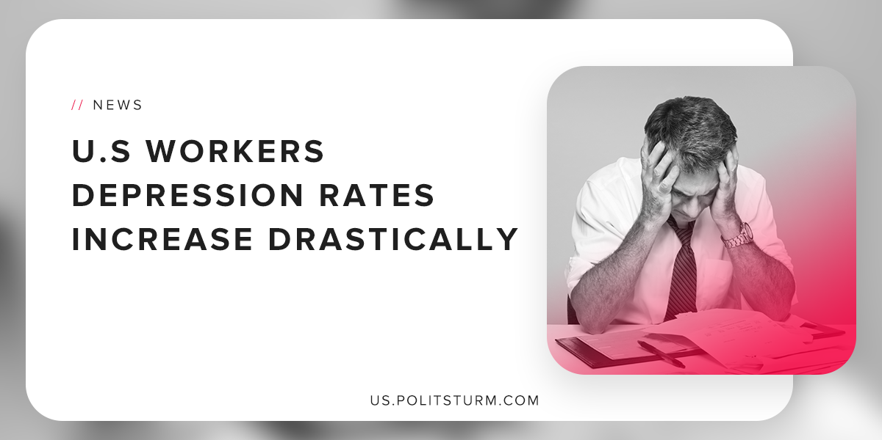

Original article
2019-05-17
1 min read

New research from mental-health app developer ‘Happify’ shows that the percentage of American workers with symptoms of depression rose 18% between 2014 and 2018. The younger generation of Americans saw an increase in depressive symptoms of 39% over the same period, double the rate of the general population.
The Anxiety and Depression Association of America in 2015 found that 16.1 million adults had experienced at least one major depressive episode in the last year. In addition to experiencing overwhelming feelings of sadness and apathy, symptoms of major depression include fatigue, feelings of worthlessness, and suicide ideation.
“Given the costs of depression for employers – about $210 billion annually and 32 days of lost productivity for each employee with a depressive disorder, this research should raise alarms about the mental health needs of American workers,” said Ran Zilca, Happify chief data science officer.
Despite acute problems with depression, corporate executives are primarily concerned with how depression interferes with the ability of the capitalists to extract maximum profit from the working class.
Sources: 1, 2

Original article

