U.S. Withdraws From Open Skies Treaty
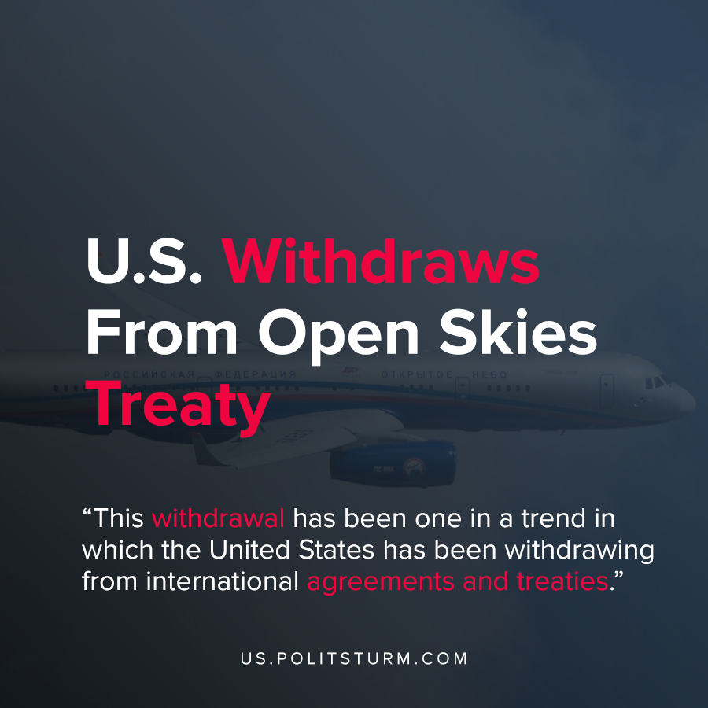

Original article
2020-05-27
1 min read

The United States State Department released a statement announcing that the U.S. will be withdrawing from the Treaty on Open Skies. This treaty allowed the participating member states to fly unarmed reconnaissance flights over any of the other member states.
In order to justify the withdrawal, the press release states that Russia has “flagrantly and continuously violated the Treaty in various ways for years”. Specifically, the State Department cites the refusal of observation flights along the regions of Abkhazia and South Ossetia, the designation of an Open Skies refueling airfield in Crimea, among other stated reasons.
“Moscow appears to use Open Skies imagery in support of an aggressive new Russian doctrine of targeting critical infrastructure in the United States and Europe with precision-guided conventional munitions. Rather than using the Open Skies Treaty as a mechanism for improving trust and confidence through military transparency, Russia has, therefore, weaponized the Treaty by making it into a tool of intimidation and threat.”
The Trump administration has stopped participating in yet another treaty with the stated intention of “reciprocal steps of our own analogous to Russia’s own provocative actions and violations”.
This withdrawal has been one in a trend in which the United States has been withdrawing from international agreements and treaties. The Trump administration also recently withdrew from the Treaty on the Elimination of Medium and Small-Range Missiles.
The economic crisis and the thirst for profit by the American bourgeois class are constantly driving the U.S. to the next imperialist war. The actions taken by the Trump administration and their “America First” policies makes this tendency transparent to those who understand Marxist-Leninist theory.
Source: 1

Original article

