U.S. Steel Announces Up To 200 Layoffs
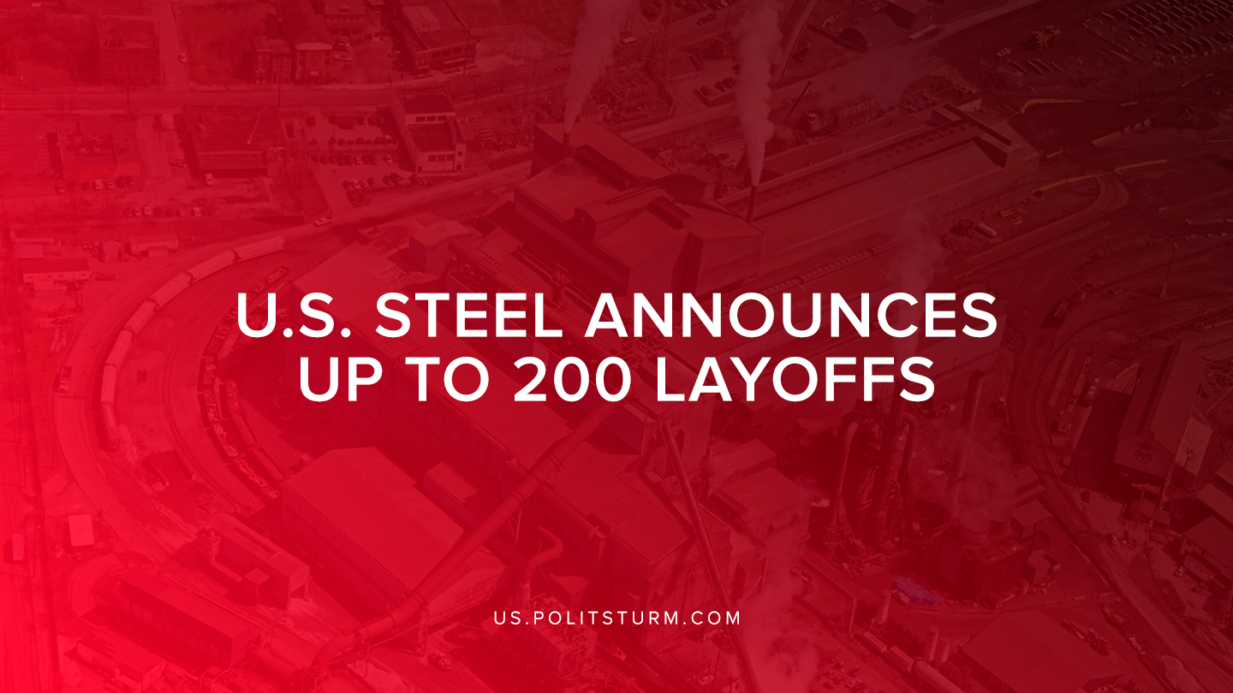

Original article
2019-08-24
1 min read

In a recent filing with the state of Michigan Department of Labor and Economic Activity, U.S. Steel corporation announced that it will be initiating layoffs that will affect approximately 200 workers. The layoffs come after the company temporarily idled operations at the B2 Blast Furnace.
The company stated that the market conditions and a reduction in consumer demand are to blame for the layoffs. The layoffs are “expected” to be temporary, but the duration of the layoffs could be longer than 6 months.
The layoffs come after Trump referenced the grand recovery of the U.S. steel industry during a speech in New Hampshire.
“We’re doing steel. Steel industry is hot. They were dumping steel all over. They were destroying our companies. U.S. steel now, all of them. They’re all expanding. The steel industry is back. It’s doing great”, said Trump.
Despite Trump’s claims that the steel industry is expanding rapidly and resurgent due to this presidency, employment in the steel industry has been on a steady decline. The so-called “rust-belt” has been decimated by the decline in Iron and Steel Mill employment. For example, Pittsburgh, Pennsylvania alone saw a decrease of steel and iron mill/ferroalloy manufacturing employment from 12,000 jobs in 1990 to 5,700 jobs in 2019.
Despite the demagoguery of Donald Trump, manufacturing employment is leaving and has left the United States and it is not coming back. Capitalists have left the United States in search of higher profits abroad and as a result the number of manufacturing jobs has declined. Only under a planned economic system, not the capitalist system governed by the law of value, would the United States be able to reinvigorate its manufacturing sector and provide stable employment to workers. Under capitalism the workers are subject to the interests of the capitalist class and the whims of the market.

Sources: 1 , 2 , 3

Original article

