U.S Order Bans Flights By Chinese Airlines
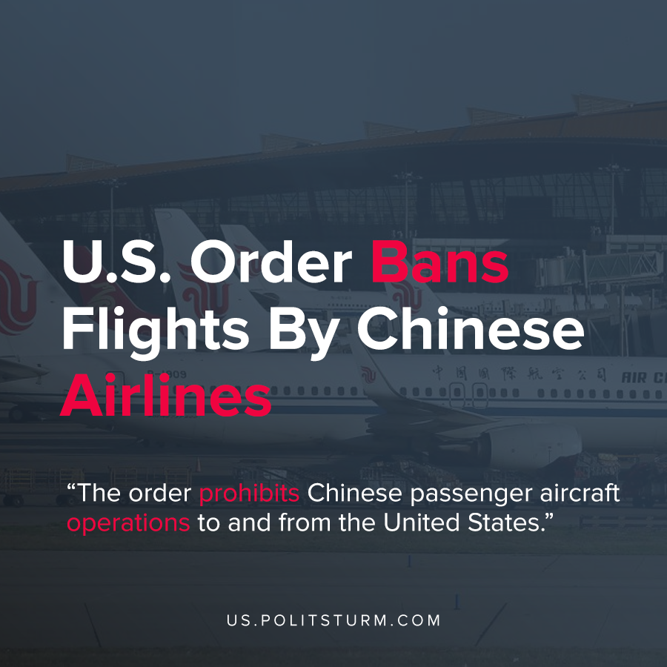

Original article
2020-06-03
1 min read

The United States Department of Transportation (DOT) released an order which prohibits Chinese passenger aircraft operations to and from the United States. The order is set to take effect on June 16th, 2020.
As justification for the move, the United States is claiming that the Civil Aviation Authority of China (CAAC) failed to permit U.S airline carriers to fully exercise their rights under their agreement. As a result, the order states that it’s purpose is “to restore a competitive balance and fair and equal opportunity among U.S. and Chinese air carriers”.
This order is just the latest display of declining relations between the United States and China which includes ongoing tariffs, restrictions, and President Trump blaming China for the coronavirus.
“China raided our factories, offshored our jobs, gutted our industries, stole our intellectual property, and violated their commitments under the World Trade Organization. To make matters worse, they are considered a developing nation getting all sorts of benefits that others, including the United States, are not entitled to”, said Trump in a recent address.
However, the capitalist economic system by its very nature is predicated on the appropriation of surplus value from the working class. As such, it was profitable for industries to shift their production to China in search of ever-greater profits. The restoration of a “competitive balance” between the United States and China does not portend any positive outcomes for the workers of either country. The economic competition between capitalist nations has the threat of breaking out in an imperialist war, as imperialist nations parasitically defend their position while developing nations aim to improve their position in the world capitalist system.

Sources: 1 , 2

Original article

