U.S. Loses 5 Million Manufacturing Jobs Over Two Decades
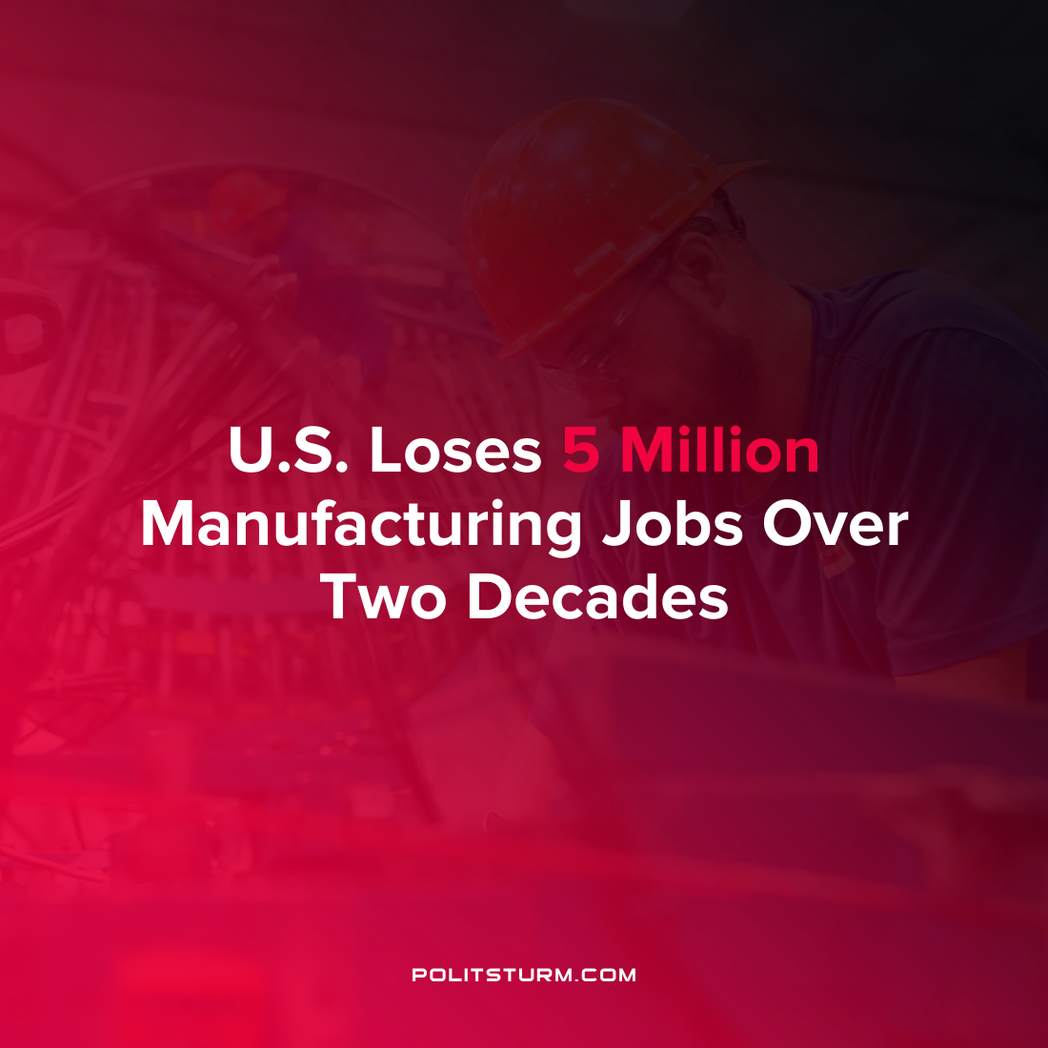

Original article
2022-02-03
1 min read

New research released by the Economic policy institute reveals the extent to which manufacturing employment has decreased in the United States over the past two decades. The findings indicate that more than 5 million manufacturing jobs were eliminated in the United States in the last two decades. Over the same time period more than 70,000 factories were closed down. Accompanying the loss in manufacturing employment was a rise in service-sector employment which is associated with lower wages, unionization rates, and fewer benefits.
The research supports the notion that manufacturing employment decreased in the United States while the trade deficit increased. One of the reasons cited for the ballooning U.S. trade deficit is exposure to international competition from “low wage workers in other countries” and the massive import of goods that are produced by the workers in these countries. In 2021, total good imports are expected to reach $2.9 trillion which is a 21.9% increase from the previous year.
Between 1998-2018 the manufacturing employment in apparel decreased 80.4%, textile employment decreased 66.3%, and Communications and audio and video equipment decreased 64.4%.
While the research blames “unfair trade, failed trade and investment deals, and, most importantly, currency manipulation” for the decline in manufacturing employment, the results are to be expected under the capitalist mode of production. In search of higher rates of profit, capital investment shifted out of the United States to wherever the rates of surplus value are higher. The long-term results are clearly decreased manufacturing employment and the loss of millions of jobs which have simply been displaced. The revival of U.S. manufacturing and employment is not to be found by legislating more equitable trade deals while maintaining the current exploitative economic structure. A planned economic system under the dictatorship of the proletariat would be able to eliminate unemployment and end the exploitation of man by man.
Source: 1

Original article

