U.S. Life Expectancy Declines by 2.2 Years
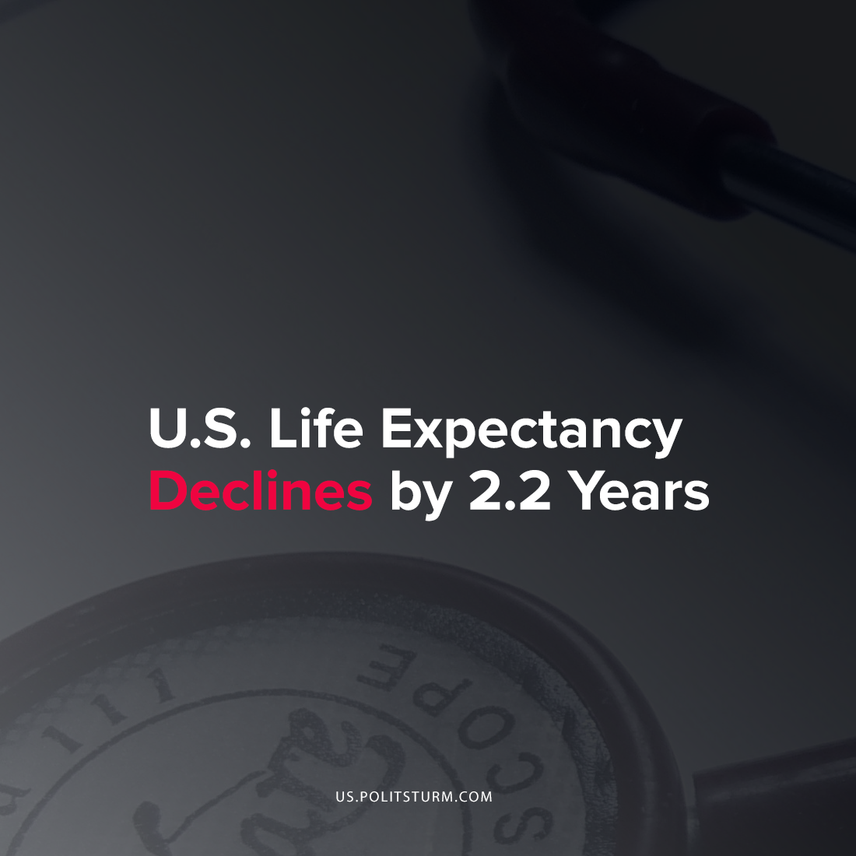

Original article
2021-10-27
1 min read

A recent study in the International Journal of Epidemiology examined the cumulative effects that the COVID-19 pandemic had on life expectancy. While life expectancy declined in 27 of the 29 countries that were included, the U.S. had one of the most stark declines in life expectancy with a 2.2 year loss of life expectancy at birth.
The study concluded that there has not been such a significant drop in life expectancy since World War II. The drop in life expectancy was largely attributable to increased mortality in those above age 60, specifically those related to COVID-19.
Since the beginning of the pandemic there have been over 740,000 reported deaths in the United States, and it is currently averaging 1,129 deaths every week.
The coronavirus pandemic and the associated increase in mortality highlight the failures of the capitalist mode of production at ensuring public health. In order to improve public health outcomes in the country, it is necessary to move beyond the limitations presented by capitalism.
Source: 1 2

Original article

