U.S. Homeless Crisis Has Hit a New Low
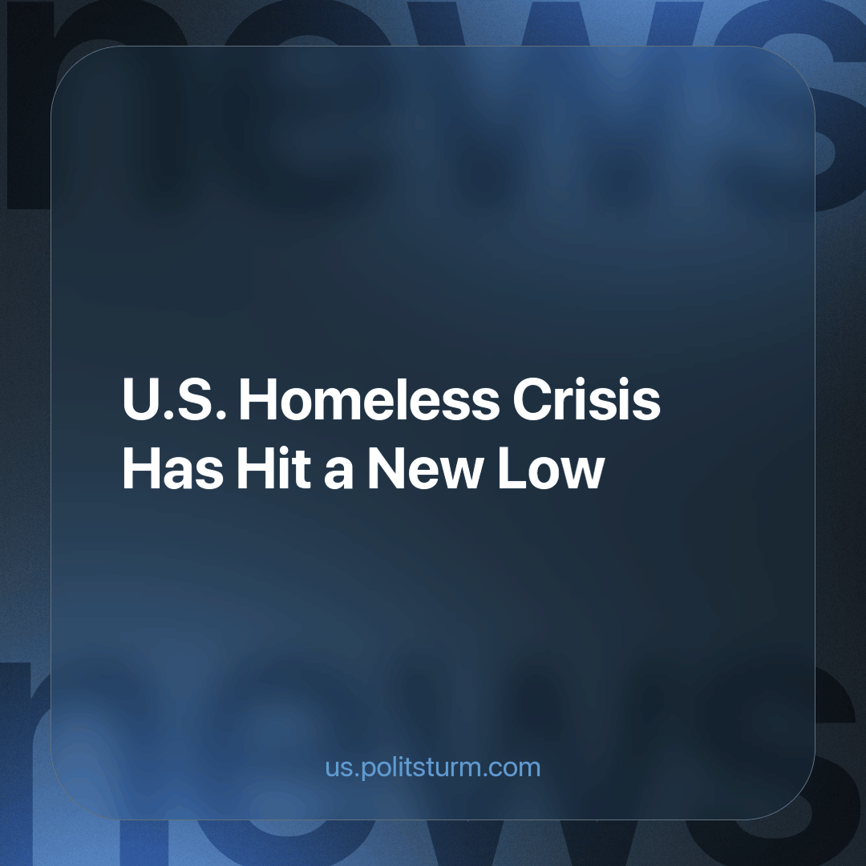

Original article
2023-10-30
2 min read

According to the New York Times, homelessness in America has hit a point where people who make even $70,000 a year cannot afford a home. All around America, the homelessness crisis intensifies as rent and housing prices skyrocket due to the continued crisis of capitalism.
This unique problem has created an opportunity for capitalists to make a new market that attempts to solve this problem with dozens of new “safe space” parking lots. "Safe spaces" are glorified parking lots that have been repurposed.
These “safe spaces” allow people to sleep in their car instead of in a home. Some of these “safe spaces” fetch absurd pricing, for example, the Colorado Safe Parking Initiative earlier this year costing an average of $1,581 a month. One bedroom in the same area costs an average of $1,655.
This new "solution" has been used for decades. For instance, LA's homeless population- 60% now live in cars. This “luxury” of having a “car home” is not a reality. A false narrative that can be easily undercut by the fact, that to access anything in America, you must have a vehicle. The car is rather than a “luxury” it's a necessity as the infrastructure in America is dedicated explicitly to cars. And does not provide adequate public transportation or distances that can be walked comfortably.
How does a person who makes $70,000 end up homeless? It is a feature rather than a ‘bug’ of the capitalist system. The vast majority of people – 58% in America, live paycheck to paycheck, meaning that if one accident or misfortune happens to that person, they will spiral into debt.
This paycheck-to-paycheck lifestyle is not a choice, like spending too lavishly but a necessity to continue the system. During the financial crash of 1973 caused by the oil crisis in America, companies' profitability suffered as consumer expenditures dropped.
To remedy this, a market opened up of credit cards and loans to expand the expenditure of consumers and increase profitability for companies and banks artificially. Credit cards and loans are essential in America due to a lack of universal healthcare or any provision by the capitalist system.
The crisis has expanded since the introduction of the credit score system in 1989 to entrap people into a debt cycle. A simplification of the system can be broken down to a purchase of anything of high value, i.e.: a car, it's a necessity to spend money and accrue a credit rating through spending on the credit card.
It's in the working class's interest to stop this absurd cycle of crisis, in favor of a system that benefits themselves rather than one that benefits the few exploiters who are part of the capitalist class.
Sources: 1,2,3,4

Original article

