U.S. Federal Tipped Minimum Wage is $2.13
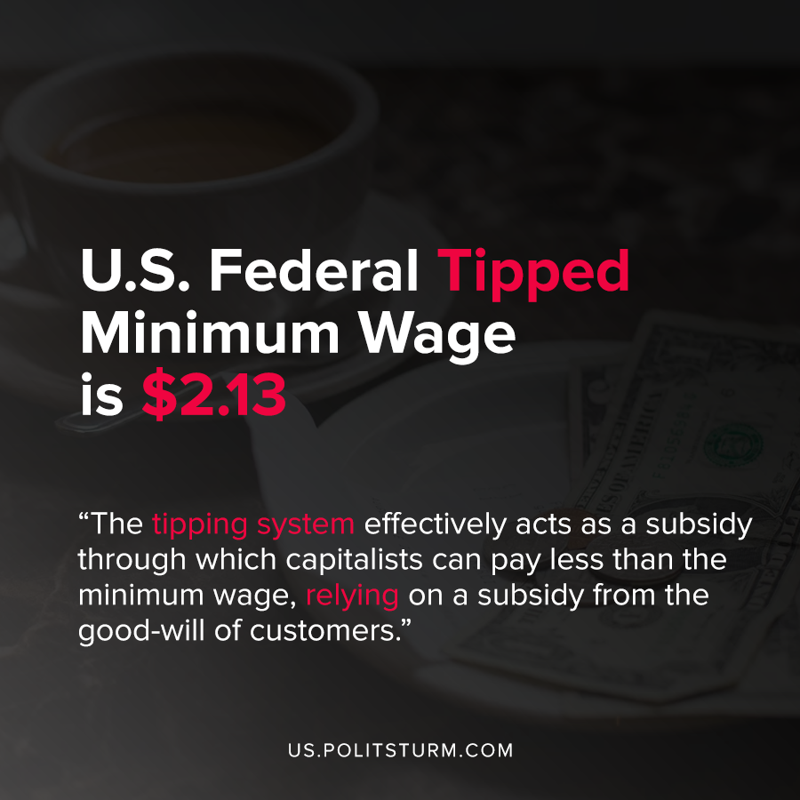

Original article
2020-08-14
1 min read

A study of the tipped minimum wage in the United States by Sylvia Allegretto and David Cooper from the Economic Policy Institute details policy surrounding tipped wages. For historical background, The Fair Labor Standards Act (FLSA) established a sub-minimum wage through which employers can pay tipped workers below the minimum wage.
The tipping system effectively acts as a subsidy through which capitalists can pay less than the minimum wage, relying on a subsidy from the good-will of customers.
According to the U.S. Department of Labor, a worker who works in an industry that typically receives tips and receives more than $30 in tips monthly, has a federal minimum wage of $2.13.
While some states require a higher tipped minimum wage, they are not required to do so and the enforcement of workers earning at least the federal minimum wage of $7.25 is lax. This leads to rampant wage theft which further increases the rate of surplus value that capitalists can extract from their laborers.
The tipped wage system in the United States, standing at a paltry $2.13 for decades for tipped workers, is an affront to the workers in this country. Tipping as a cultural practice is common in this country because it is a wage subsidy that benefits the dominant class in society, the capitalists. A socialist economy would eliminate tipping and ensure that workers were not robbed of their hard earned money by the capitalist class, along with several other benefits that are non-existent to American workers.
Sources: 1 , 2

Original article

