U.S. Economy Suffers 32.9% GDP Contraction
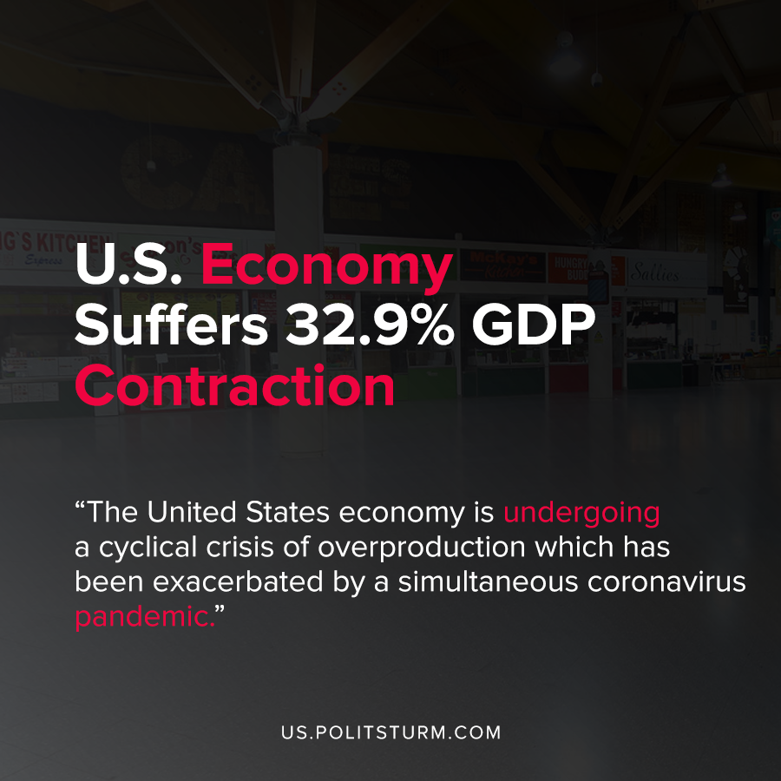

Original article
2020-07-31
2 min read

Data released by the Bureau of Economic Analysis (BEA) showed a 32.9% annualized decrease in U.S. Gross Domestic Product (GDP). This is a common indicator used by bourgeois economists to measure the dollar growth of spending on goods and services in the economy.
There were significant declines in personal expenditures, exports, imports, fixed investment, residential investment, inventory investment, and state and local government spending.
In addition, over 30 million Americans were claiming government unemployment benefits and over 1.4 million Americans filed unemployment claims last week.
The United States economy is undergoing a cyclical crisis of overproduction which has been exacerbated by a simultaneous coronavirus pandemic. While this annualized 32.9% decrease in gross domestic product is an estimate for the second quarter of 2020, the United States has failed to effectively control the spread of the coronavirus up to the present time.
While monopolies and the oligarchs have capitalized from the crisis, an astronomical number of workers have lost their jobs and struggle to pay for necessities and adequate health care. The capitalist system, based on the appropriation of profit, structurally experiences recurrent crises of overproduction that are predictable and recurrent.
The competition of the market and the recurrent glut of commodities periodically exceeds the effective monetary demand necessary for their circulation. Capitalists exploit their laborers and flood the market with commodities to extract the maximum profit. This anarchic system of production, in addition to having periodic crises, has other obvious negative repercussions for the workers.
The American capitalists oppose a system of universal healthcare and use their political power to make the workers dependent on employer-provided insurance coverage.
The American government which serves the capitalist class and relies heavily on decentralized state and local governance has predictably failed to provide an effective response during the crisis phase of the capitalist business cycle.
Whereas capitalism serves the interests of the capitalist class, socialism would serve the interests of the workers and provide for their well-being while simultaneously not being subject to periodic crises of overproduction. A centralized economy and government of the working class would be able to provide both balanced economic growth and provide for the healthcare of the American workers in a manner that is impossible under capitalism.
Sources: 1 , 2 , 3

Original article

