U.S. Economy Officially Enters Recession
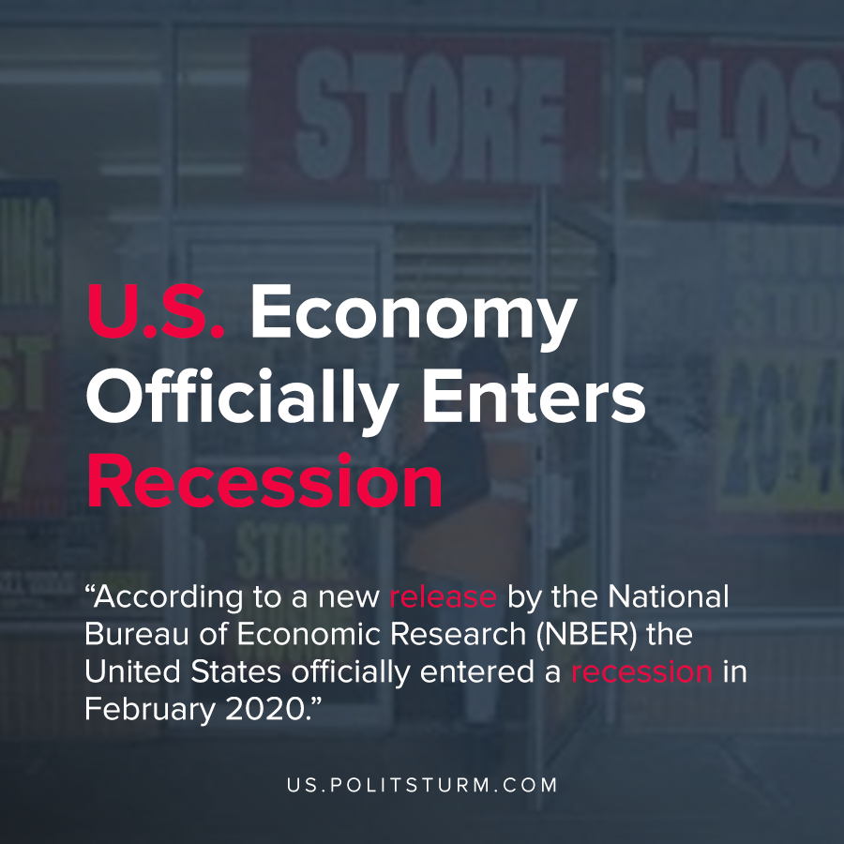

Original article
2020-06-09
1 min read

According to a new release by the National Bureau of Economic Research (NBER) the United States officially entered a recession in February 2020. This new crisis of overproduction came after the longest business cycle in U.S history dating back to 1854.
A recession is categorized by a significant decline in economic activity that is visible in production, employment, and other factors. A recession is also characterized by a broad contraction of the economy as a whole, not being confined to one or several sectors.
Whereas the bourgeois economists view recessions as a natural economic occurrence in the economy, a proper Marxist understanding of economics views recessions specifically as crises of overproduction. Approximately every 10 years, capitalist economies are subject to crises as commodities are overproduced relative to the supply of money required to circulate them at profitable prices for the capitalists.
As a result, economic activity is dramatically slowed as inventories are liquidated, unemployment increases dramatically, and the capitalist system of expanded reproduction slows considerably. The contradiction between the social nature of production, and the private accumulation of its results becomes apparent. Under a socialist mode of production, crises of overproduction would be eliminated completely as production would be conducted in accordance with a rational plan that would not be subject to the overproduction crises of anarchic, capitalist production.

Original article

